**Table of Contents**

1. Introduction  
   1.1 Purpose of This Manual  
   1.2 Overview of Micromouse and Simulink
2. Required Environment and Preparation  
   2.1 Recommended Versions  
   2.2 Hardware Preparation
3. Simulation  
   3.1 Launching MATLAB and Verifying Files  
   3.2 Overview of the Simulation Model  
   3.2.1 Sensor Model  
   3.2.2 Control Model  
   3.2.3 Plant Model  
   3.2.4 Environment Model  
   3.3 Executing the Simulation and Result Verification  
   3.4 Model Improvement and Applications
4. Hardware Blockset  
   4.1 STM32 Hardware Configuration and Functions  
   4.2 Environment Setup  
   4.2.1 Simulink Configuration  
   4.2.2 STM32CubeMX Configuration  
   4.3 Overview of STM32F3 Series Blockset  
   4.3.1 Input Blocks  
   4.3.2 Output Blocks  
   4.4 Implementation on Actual Hardware
5. Conclusion  
   References

**1. Introduction**

**1.1 Purpose of This Manual**

This manual is intended for students, engineers, and educators interested in Model-Based Design (MBD), aiming to facilitate the acquisition of skills for operating and controlling a Micromouse simulation model using Simulink. Ultimately, it seeks to enable the implementation of control models onto actual hardware.

In practical product development, manufacturing physical prototypes in the initial stages often leads to increased risk of failure, as well as higher time and cost. Utilizing simulation enables verification through models in advance, thereby increasing the probability of success. This manual provides a detailed explanation of the steps from downloading the simulation model, initial setup, usage of main blocks, to parameter configuration.

Through this manual, it is expected that readers will establish a foundation for model-based development applicable to various fields, including robotics, automotive engineering, and drones.

**1.2 Overview of Micromouse and Simulink**

**What is Micromouse?**

Micromouse is a small autonomous mobile robot, primarily featured in two types of competitions: line-tracing and maze-solving. In line-tracing, the robot follows a line drawn on the surface, while in maze-solving, it explores a maze and aims to reach the goal via the shortest path. These competitions provide practical learning opportunities in robotics, control theory, and algorithm research and education.

**What is Simulink?**

Simulink, provided by MathWorks, is a graphical programming environment for modeling, simulating, and analyzing dynamic systems. It enables visual design through block diagrams and is widely used for the development of control and signal processing systems. Simulink works in conjunction with MATLAB, allowing for complex numerical computations.

**Relationship Between Simulink and Micromouse**

By using Simulink, it is possible to virtually simulate the behavior of a Micromouse and to develop and verify control algorithms. The simulation environment allows for emulation of sensor and actuator behavior without actual hardware, enabling verification of theoretical operation and optimal control strategy design before physical implementation. This manual aims to provide guidance for constructing Micromouse simulation models and acquiring control techniques using Simulink.

**2. Required Environment and Preparation**

**2.1 Recommended Versions**

For line-trace simulation of Micromouse, the following MATLAB product versions are recommended. Select the appropriate folder according to your MATLAB version.

* **Simulation**
  + **LineTrace_Simulation_2024b**: Recommended for MATLAB 2024b
  + **LineTrace_Simulation_2025a**: Recommended for MATLAB 2025a or later
* **Hardware**
  + **LineTrace_Hardware_Ver1**: For older versions, recommended for MATLAB 2024b or later
  + **LineTrace_Hardware_Ver2**: For the new version V2, recommended for MATLAB 2024b or later

**Unzipping Procedure:**

1. Unzip the folder corresponding to your selected version (2024b or 2025a).
2. Ensure the following three files are contained within the folder:
   * **LineTraceSample_2024b.slx** or **LineTraceSample_2025a.slx**
   * **Course.stl**
   * **Tracer.stl**

**Simulation Toolbox:**

* **Simulink 3D Animation Toolbox**
* **Computer Vision Toolbox**

**Hardware Toolbox & Support Pacakage**

* **Simulink**
* **Embedded Coder**
* **MATLAB Coder**
* **Simulink Coder**
* **Embedded Coder Support Package for STMicroelectronics STM32 Processors**

**2.2 Hardware Preparation**

The hardware used in this manual is the Training Tracer by RT Corporation, equipped with an STM32 CPU. For actual hardware control, it is necessary to install the STM32 hardware support package on the MATLAB side.

**3. Simulation**

**3.1 Launching MATLAB and Verifying Files**

1. Launch MATLAB and set the current folder to display **LineTraceSample202XX.slx** (to enable reading of **.stl** files).
2. Double-click **LineTraceSample202XX.slx** and confirm the model opens correctly.

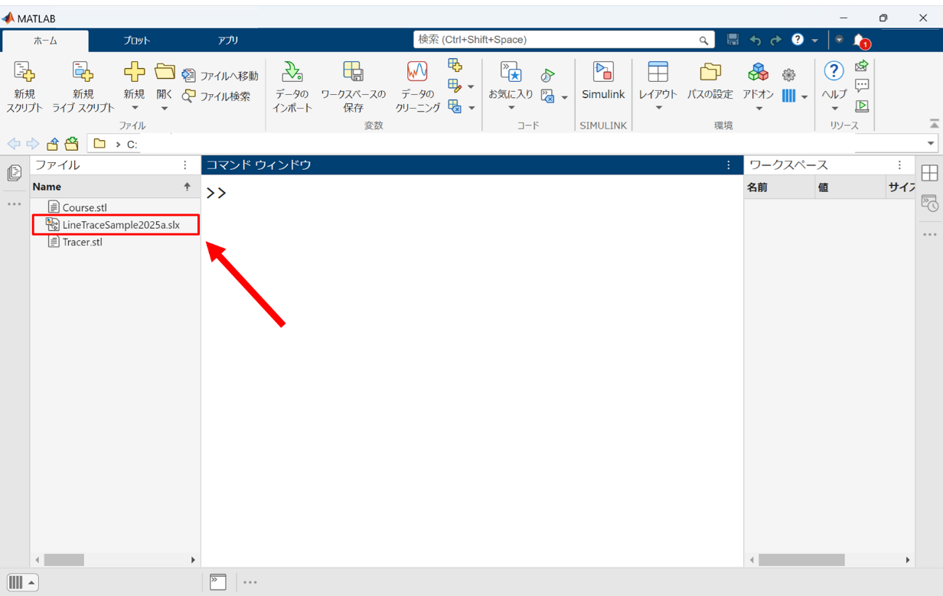

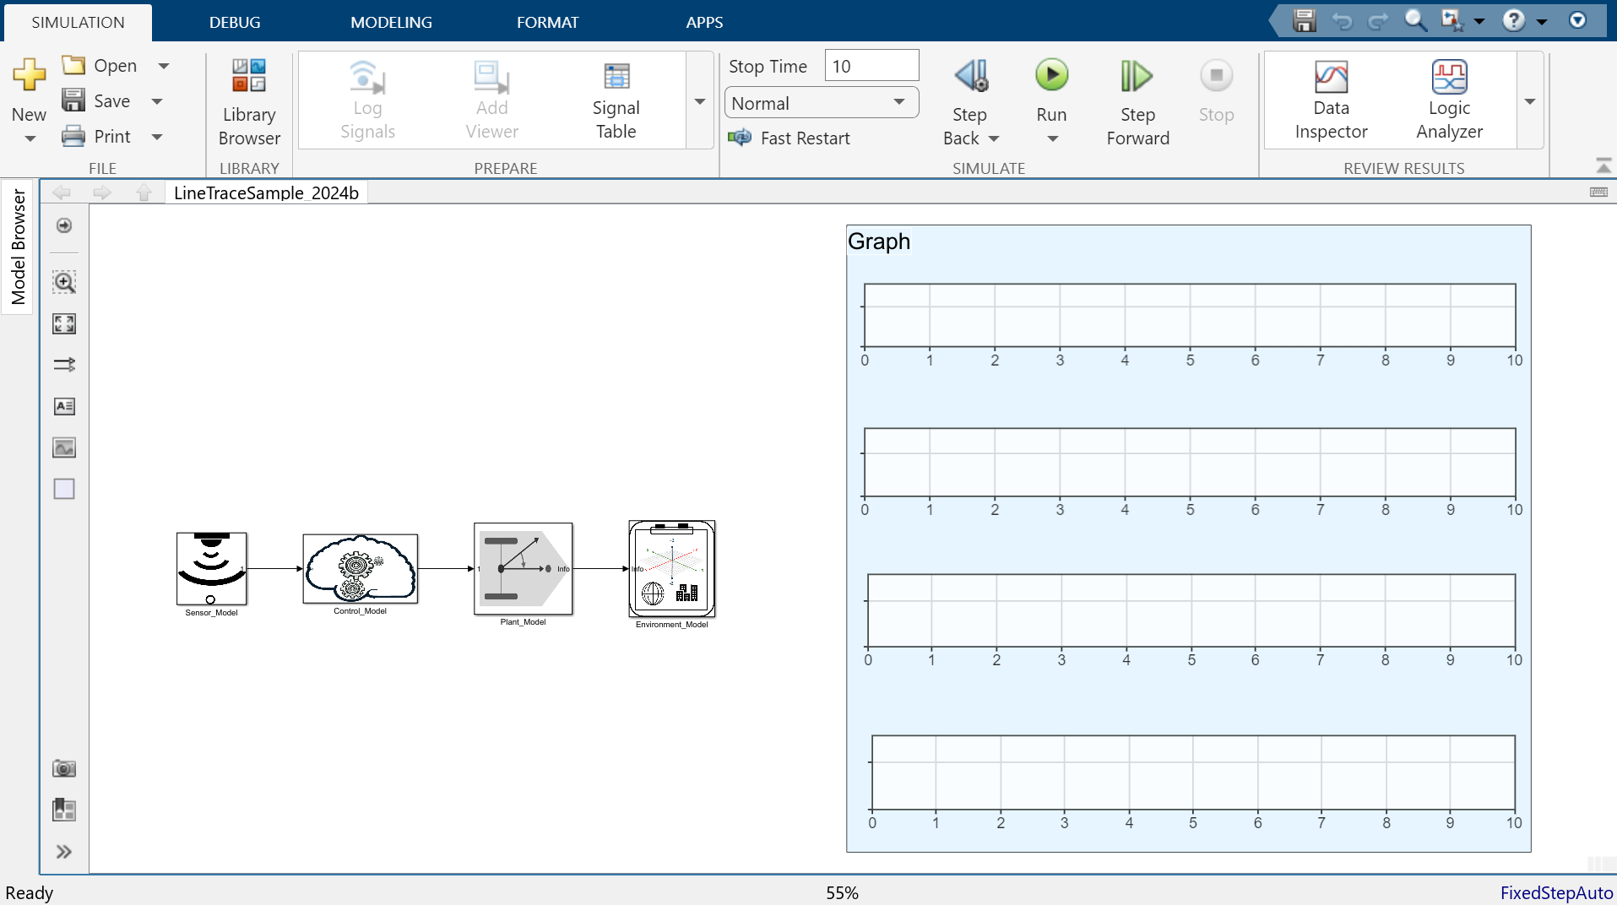

**3.2 Overview of the Simulation Model**

This simulation model consists of the following four subsystems.

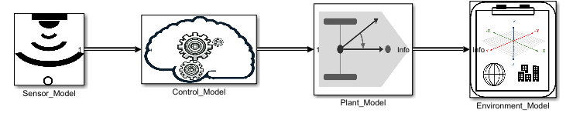

**3.2.1 Sensor Model**

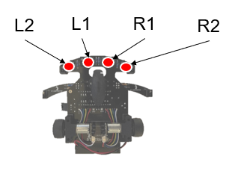

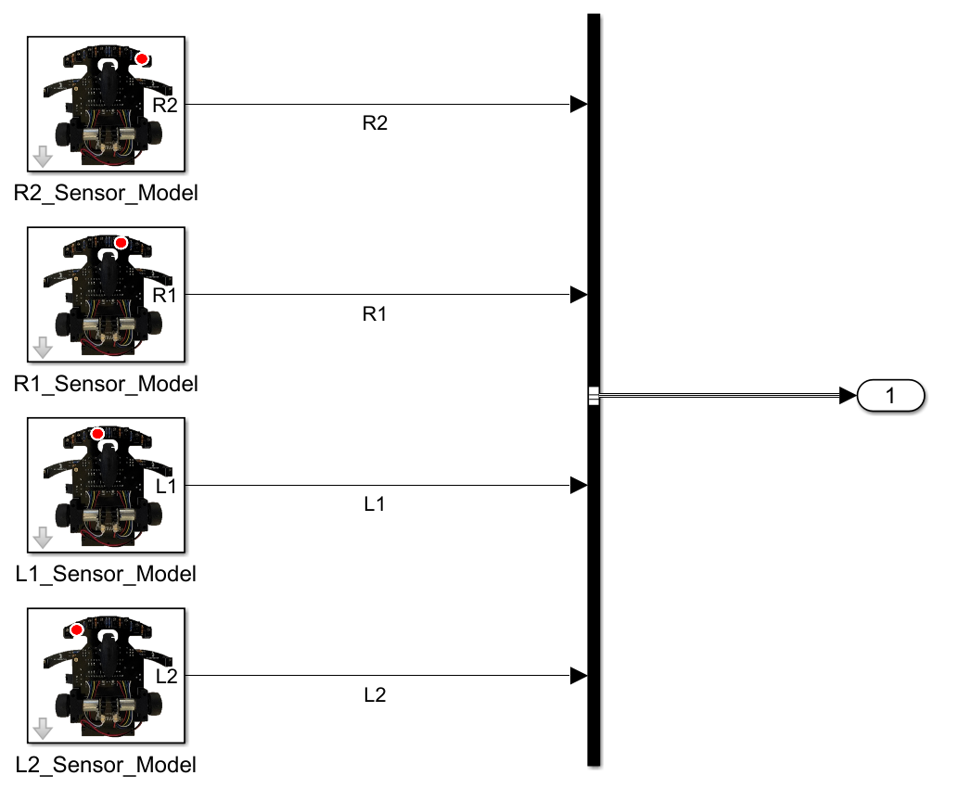

**Input:**Using the X and Y coordinates and yaw angle of the training tracer used in the environment model, each camera sensor is moved to follow the tracer model, and new sensor data is acquired accordingly.

**Output:**The RGB data obtained from the camera sensors is binarized and combined to generate signal data for a pseudo LED sensor.

**Parameters:**Double-clicking each sensor block opens a window where you can set the initial position (X, Y, Z coordinates) and initial orientation (roll, pitch, yaw angles) of the sensor.

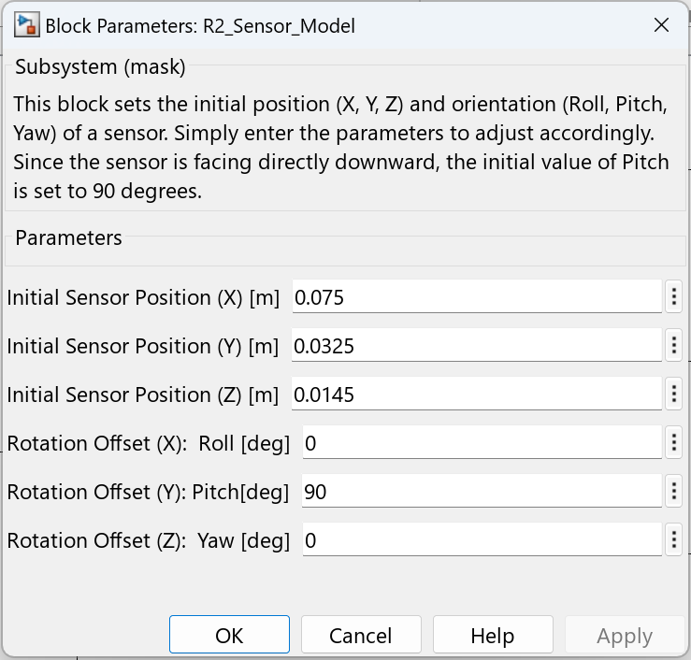

* The Training Tracer is equipped with four front-facing LED sensors (L2, L1, R1, R2).
* In this model, RGB camera sensors emulate the LED sensors. Simulink 3D Animation is used to binarize and aggregate RGB data, generating pseudo LED sensor signals.
* Parameters such as X/Y/Z coordinates and roll/pitch/yaw angles can be set for the sensor block (pitch angle 90° directs the camera downward).

**Note:**

* The sensor's origin (zero point) is set as the rotation center of the tracer.
* As of 2025, the model addresses optimization of the camera sensor's recognition range and issues such as wall/floor penetration by adjusting the Z-axis offset.

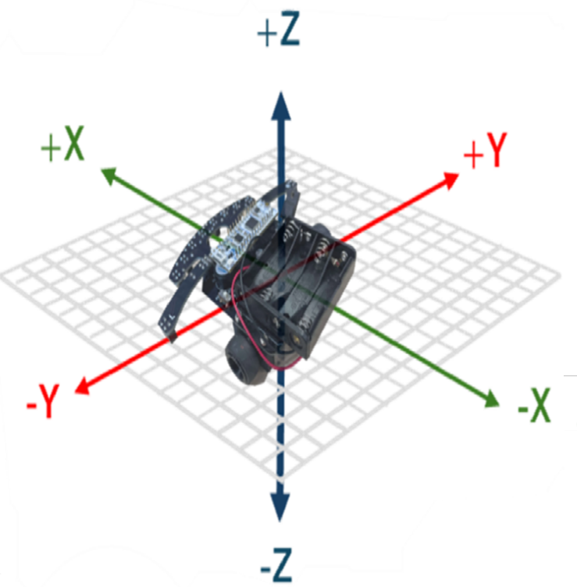

**3.2.2 Control Model**

* The left and right DC motors are independently controlled by PWM (speed) and Direction (rotation direction).
* The four sensor data are divided into left and right, and PID control is implemented to minimize the difference.
* The default average speed is 60 [PWM].

**Inputs/Outputs:**

* Inputs: L2, L1, R1, R2 sensor signals
* Outputs: PWM values (0-99), Direction values (0: CW, 1: CCW)

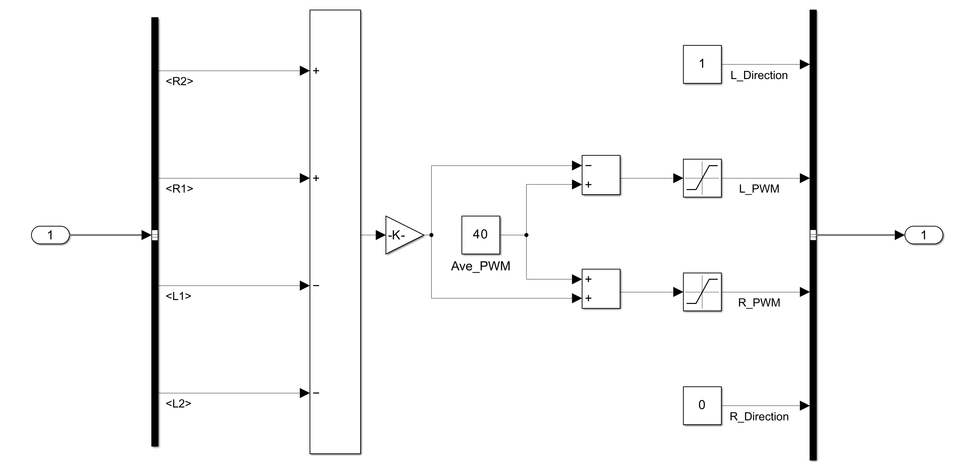

**3.2.3 Plant Model**

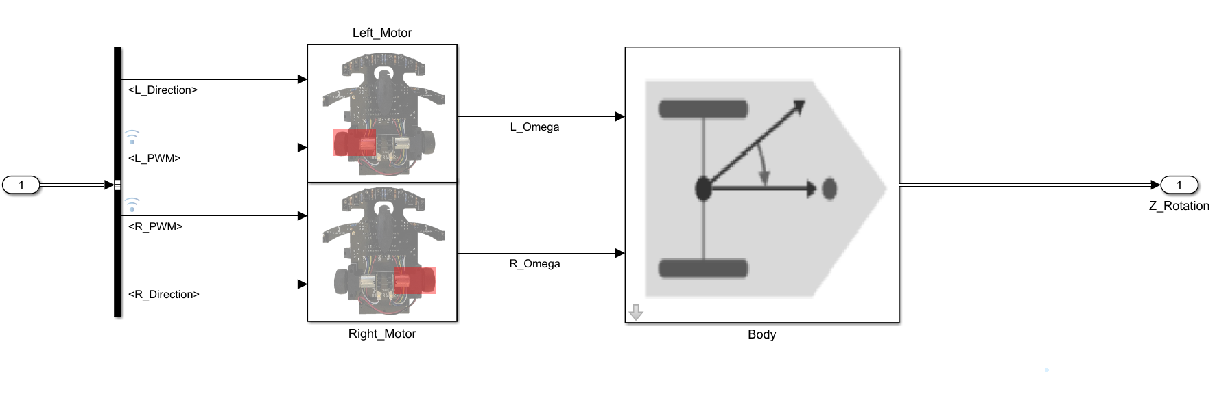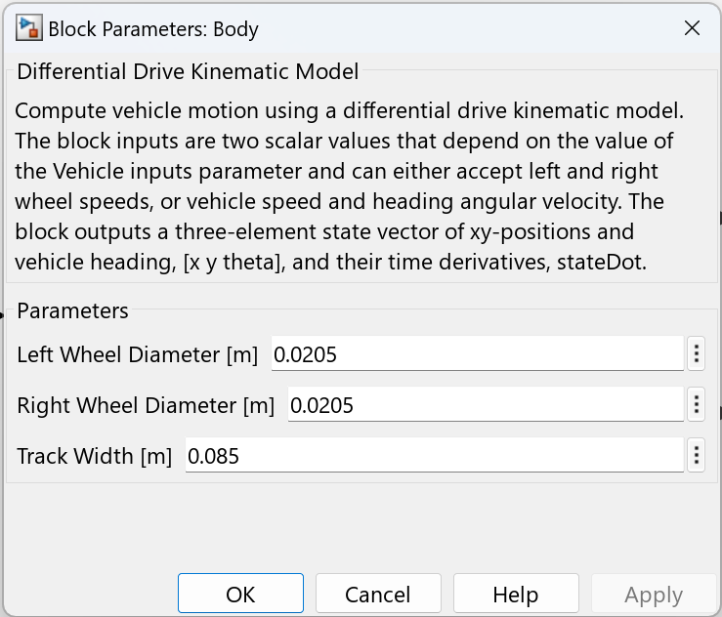

* Motor subsystem: System identification via a 1-D lookup table, converting PWM values to rotational speed.
* Body subsystem: Based on the kinematic equations of a differential drive robot, position and orientation are calculated by integrating angular velocity and speed.
* Parameters such as tire diameter and wheelbase can be set (Ver1: 20.5mm, Ver2: 24mm).

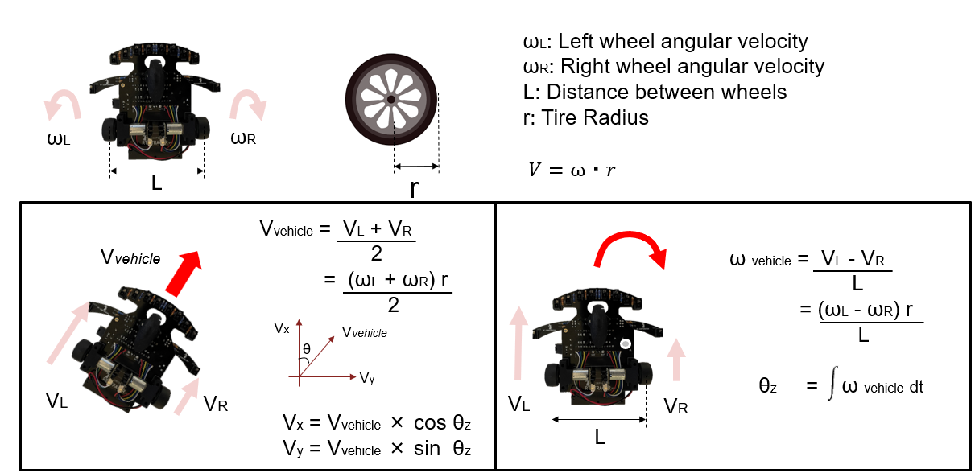

**3.2.4 Environment Model**

The environment model includes the following six blocks: Tracer, Initial_Position_Offset, Course, Ground, Behind_Camera, and Simulation 3D Scene Configuration.

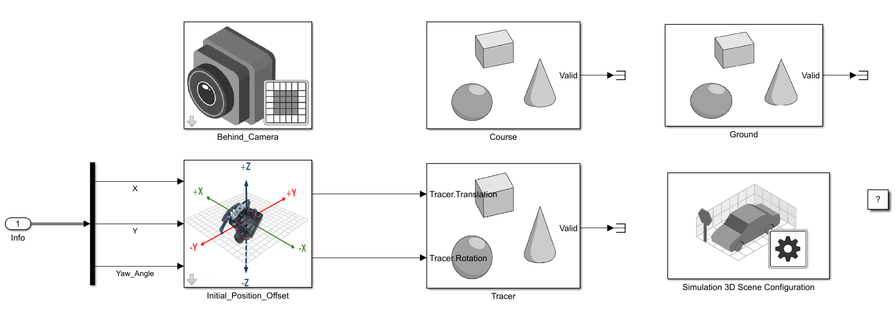

* **Tracer** block: Displays the CAD file (**Tracer.stl**) using 3D animation. Set the Actor Scale is set to 0.01 since the STL file was imported in centimeters, the scale is set to 0.01 to convert it to meters. Be sure to pay attention to unit conversion when using the model.
* 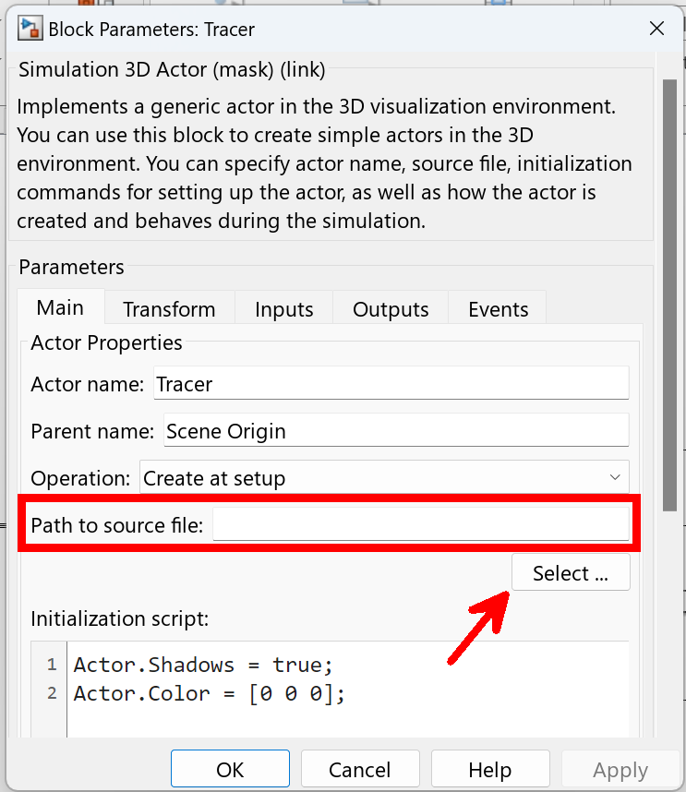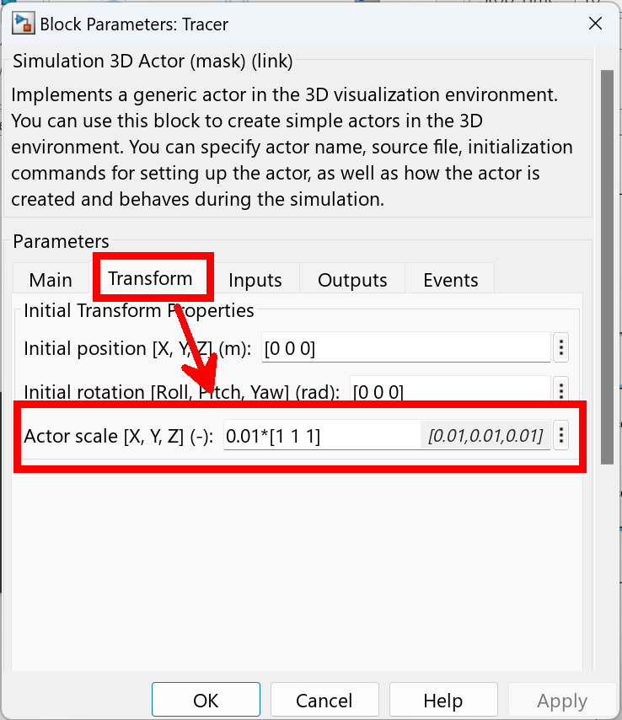
* **Course** block: Displays the course CAD file (**Course.stl**). Color can be changed via Actor.Color.
* 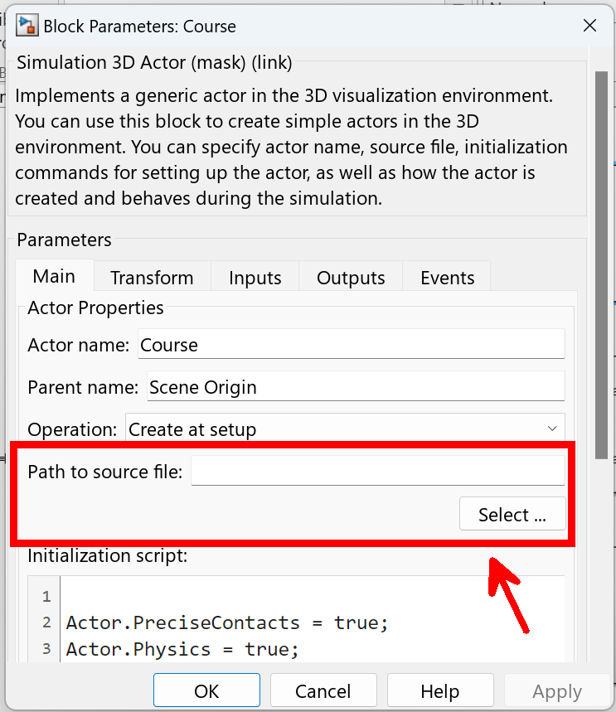
* 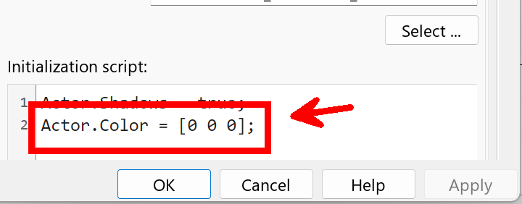
* **Ground** block: Generates a 3[m] × 3[m] × 0.001[m] ground plane.
* 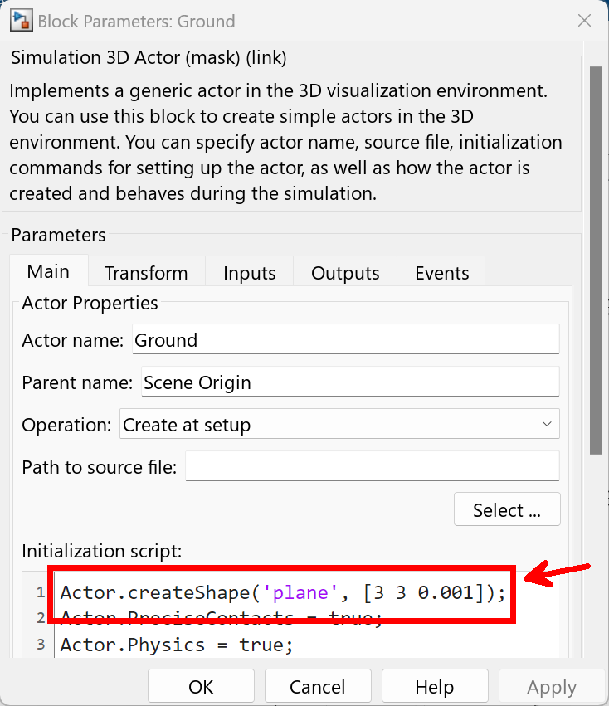
* **Simulation 3D Scene Configuration**: Basic 3D simulation settings and initial camera viewpoint configuration.
* 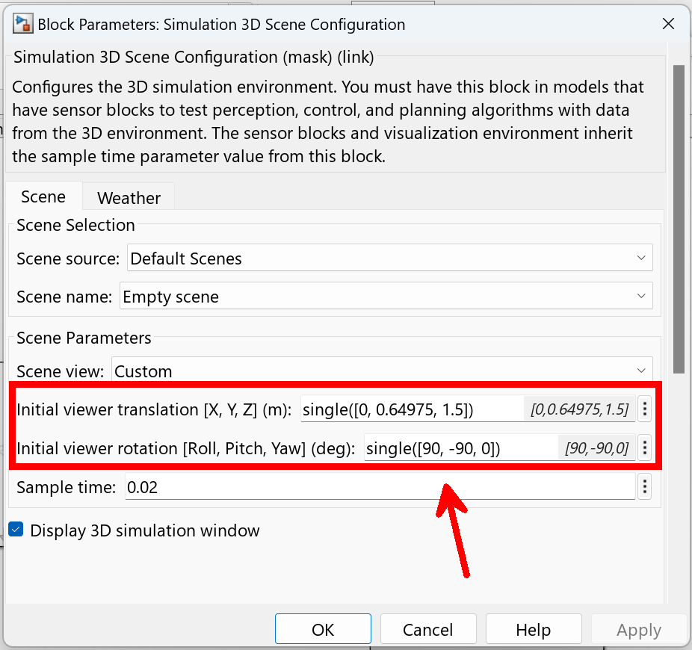
* **Initial_Position_Offset** block: Adjusts the initial position and orientation of the CAD data.
* 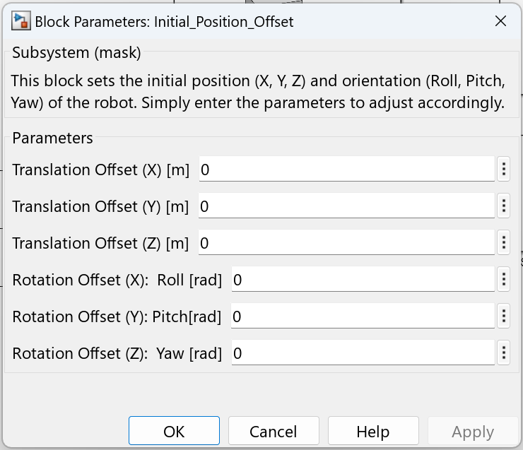

**3.3 Executing the Simulation and Result Verification**

You can run the simulation with default settings. If you just want to try it out, make sure Course.stl and Tracer.stl are in MATLAB's current folder, then press the run button. The first time you run it, you'll be prompted to install the free Unreal Engine for 3D animation rendering. Follow the instructions to complete the installation.

* Select the **.stl** files in the environment model and execute the simulation with default settings.
* If Unreal Engine (free) is not installed, follow the instructions to install it.
* 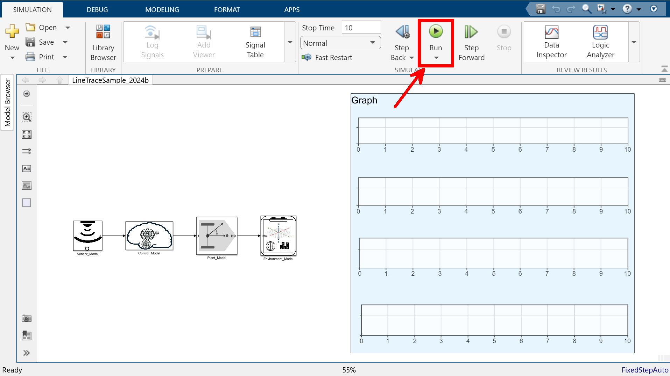
* Robot behavior can be confirmed via animation, and consistency with sensor data can be verified.
* 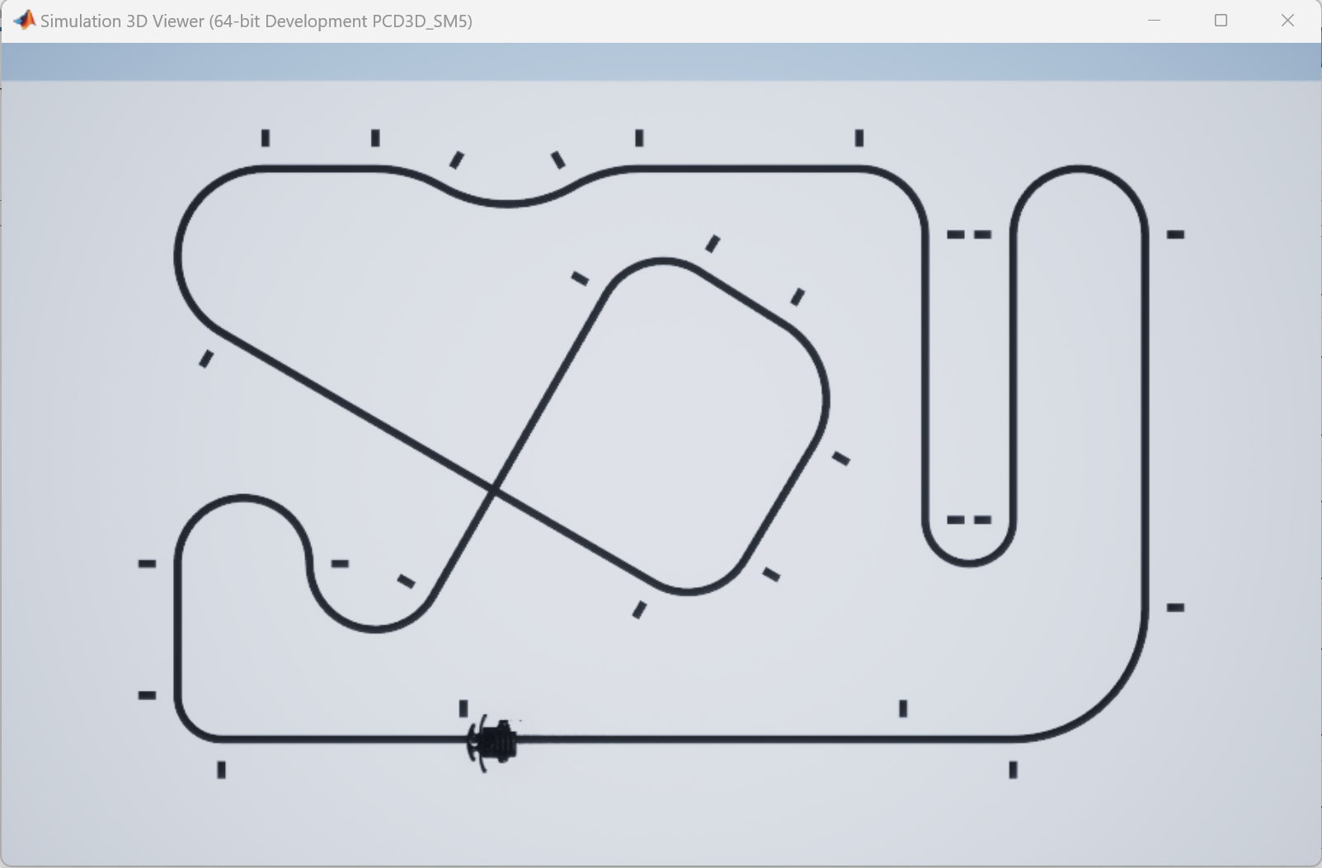
* 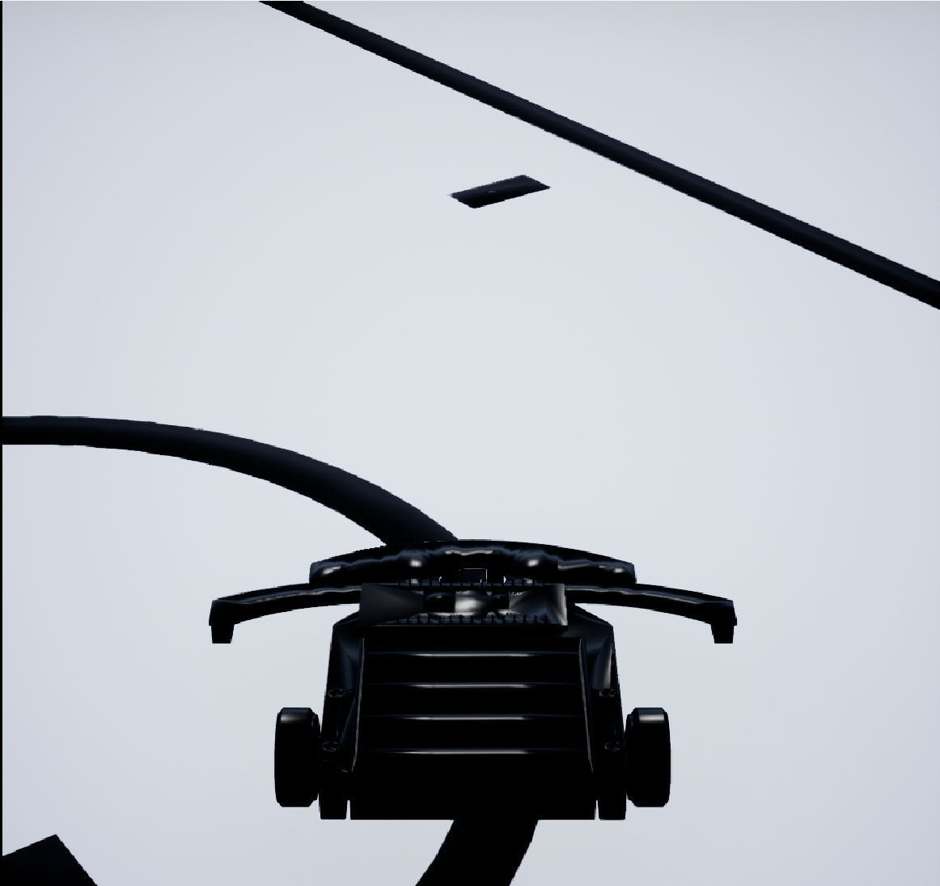
* If necessary, right-click signal lines to add "Log Selected Signal" and use the Data Inspector to view signals.
* 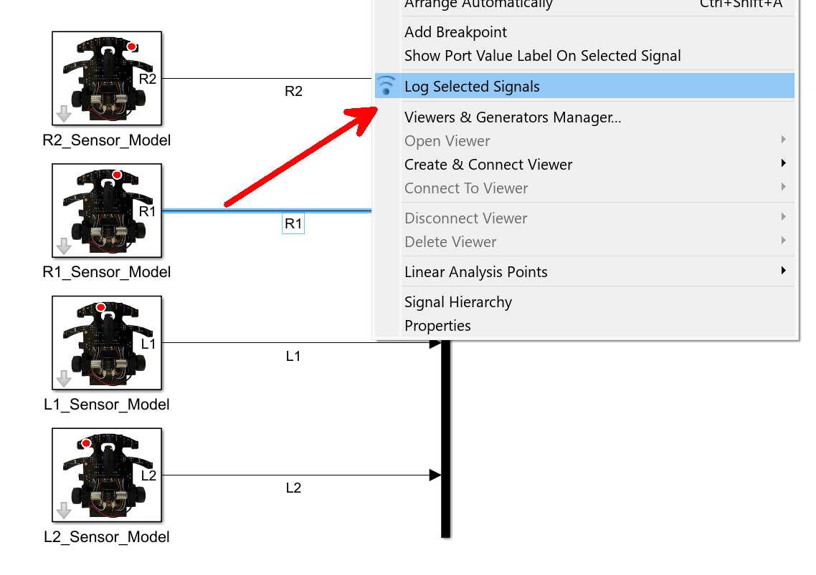
* 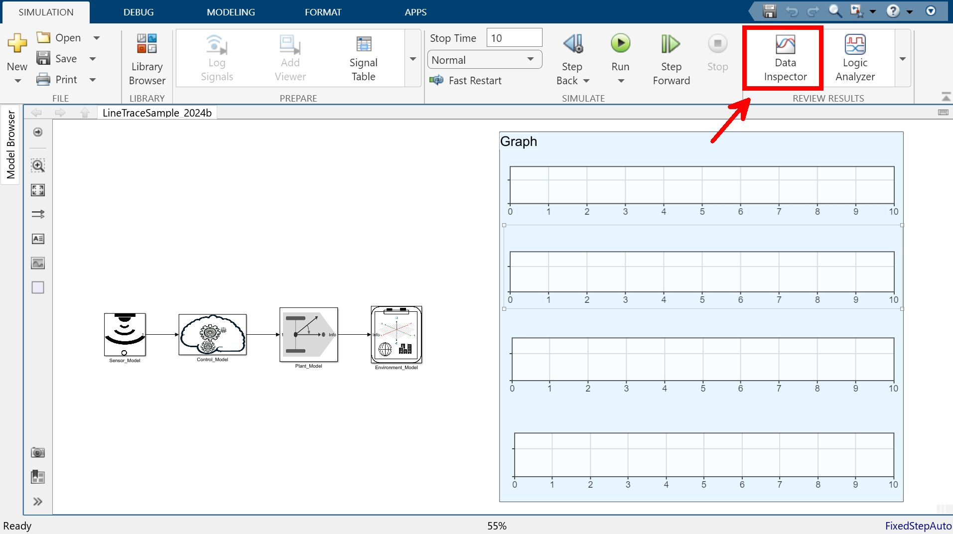
* 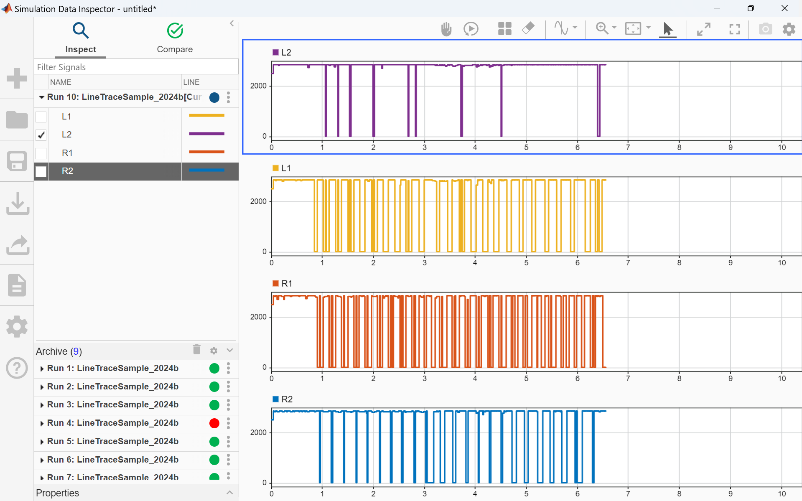

**3.4 Model Improvement and Applications**

By improving and applying each subsystem, more advanced simulations are possible. Main examples of improvements are shown below.

| **Item** | **Description** |
| --- | --- |
| Sensor Signal | Addition of noise |
| Sensor Type | Use of sensors other than RGB cameras, such as LiDAR |
| Number of Sensors | Increase in number |
| Sensor Substitution | Replacement with real-world data or external control hardware |
| Control Model | Higher speed and accuracy |
| Motor Model | Improved accuracy |
| Air Resistance | Addition to the differential drive model |
| Friction | Addition to the differential drive model |
| Environment Model | Introduction of custom robot bodies |

This model is designed as a highly versatile demonstration. By improving and applying each element, it can be utilized in various fields such as automobiles, rockets, robots, drones, aircraft, railways, and ships.

**4. Hardware Blockset**

**4.1 STM32 Hardware Configuration and Functions**

* The hardware blockset is constructed based on the Training Tracer by RT Corporation, equipped with an STM32 F3xx series CPU.
* Inputs: LED light sensors, tactile switches, IMU, battery voltage sensor, encoders.
* Outputs: Motors, LED lights, buzzer.
* Blocks used: ADC Block, IMU Block, Digital Read Block, Encoder Block.
* 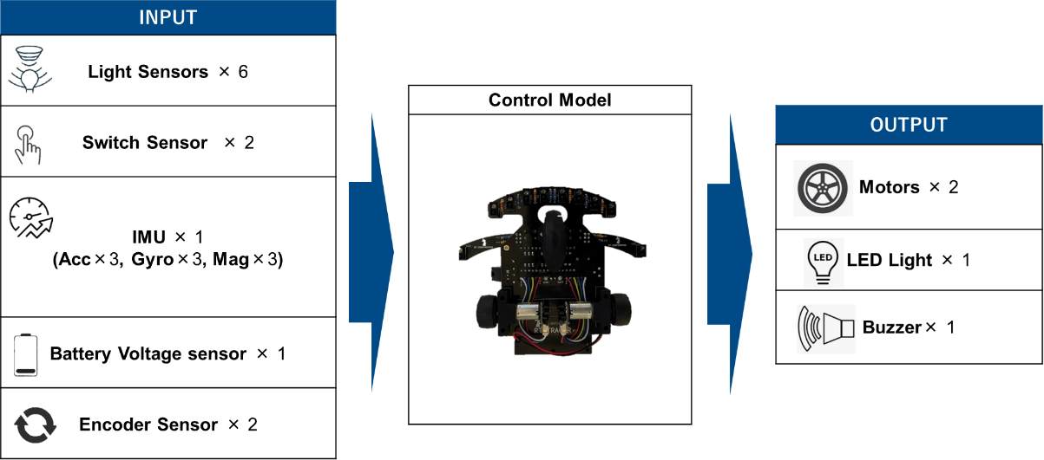

**4.2 Environment Setup**

**Required Equipment**

* PC
* USB-Micro Type B cable
* Training Tracer unit
* Four AAA batteries
* 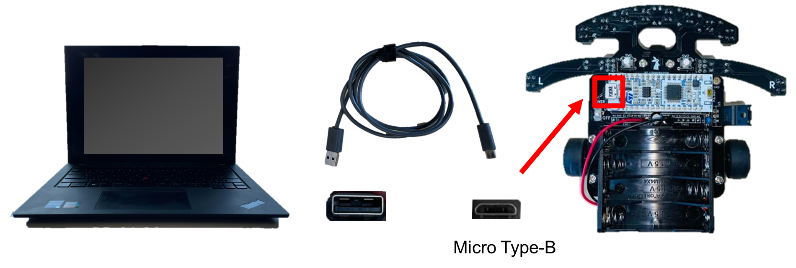

**Installing the Hardware Support Package**

1. On MATLAB, select "Add-Ons" → "Get Hardware Support Packages."

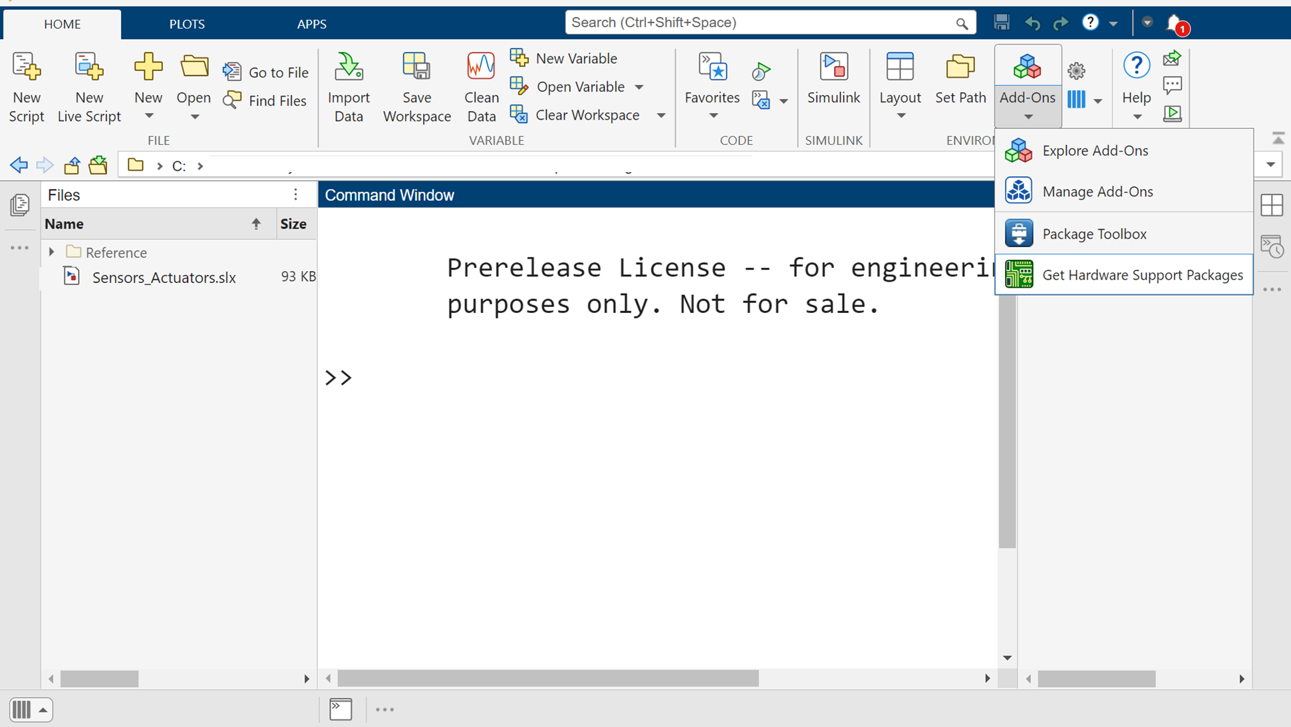

1. Enter "stm32" in the search bar and search.

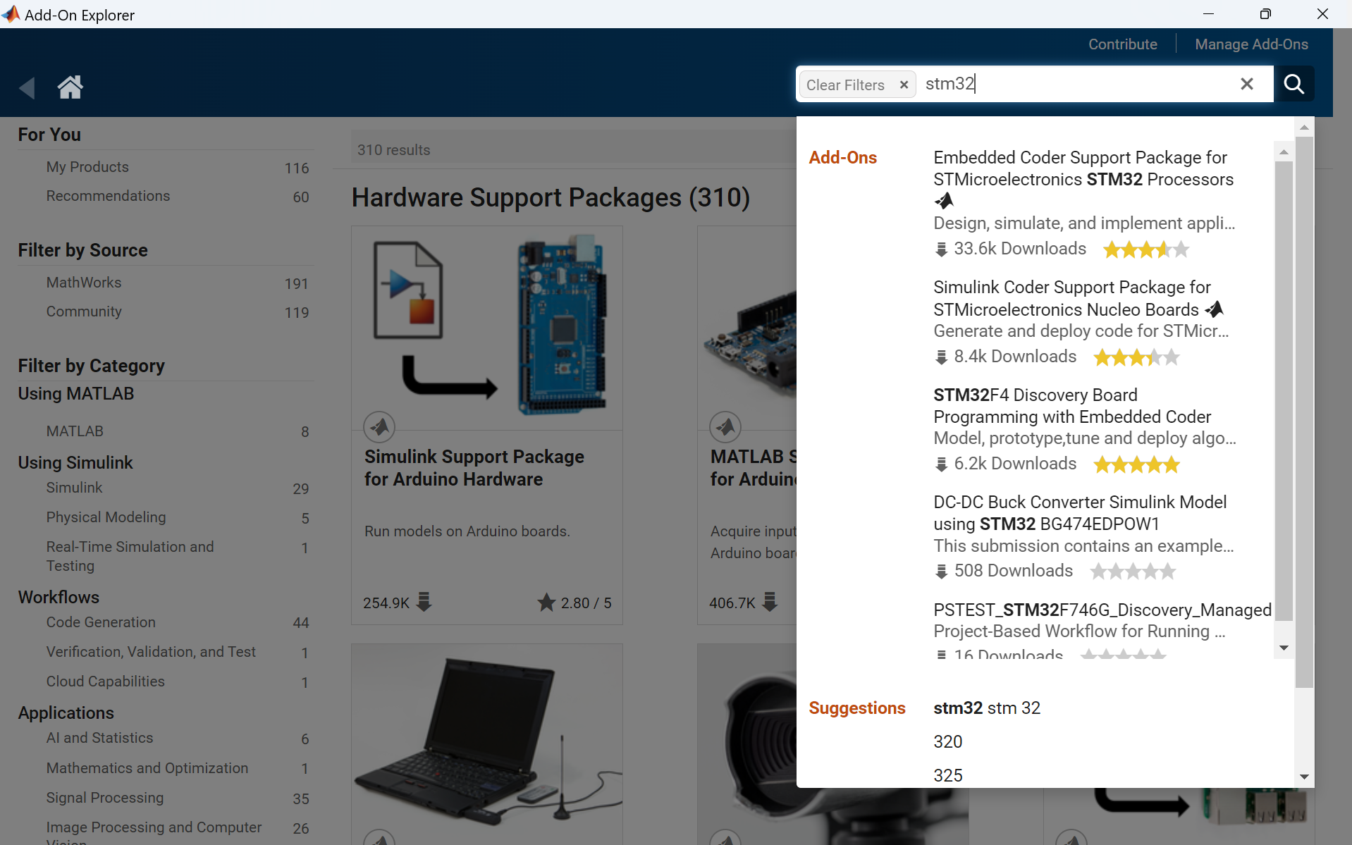

1. Select and install "Embedded Coder Support Package for STMicroelectronics STM32 Processors."

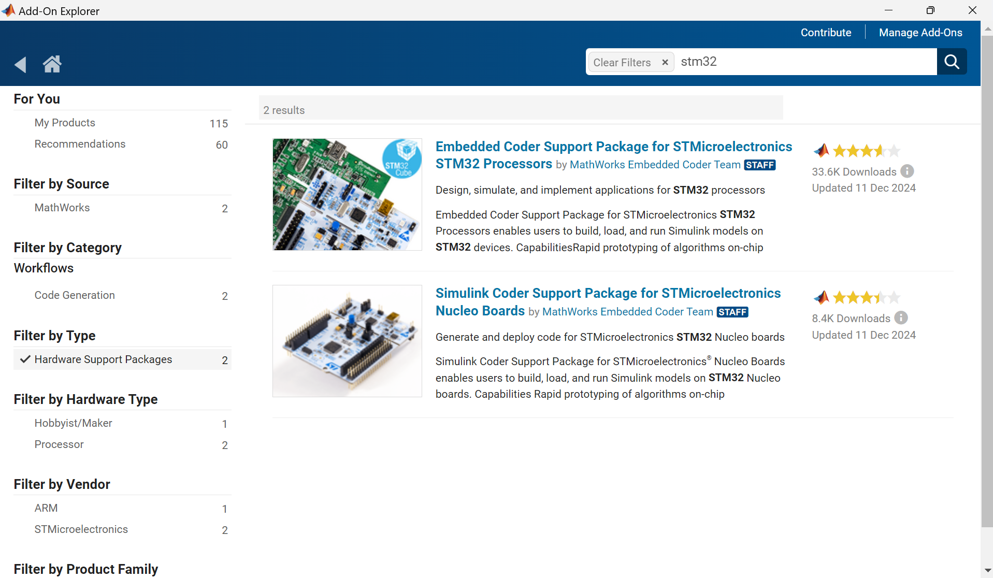

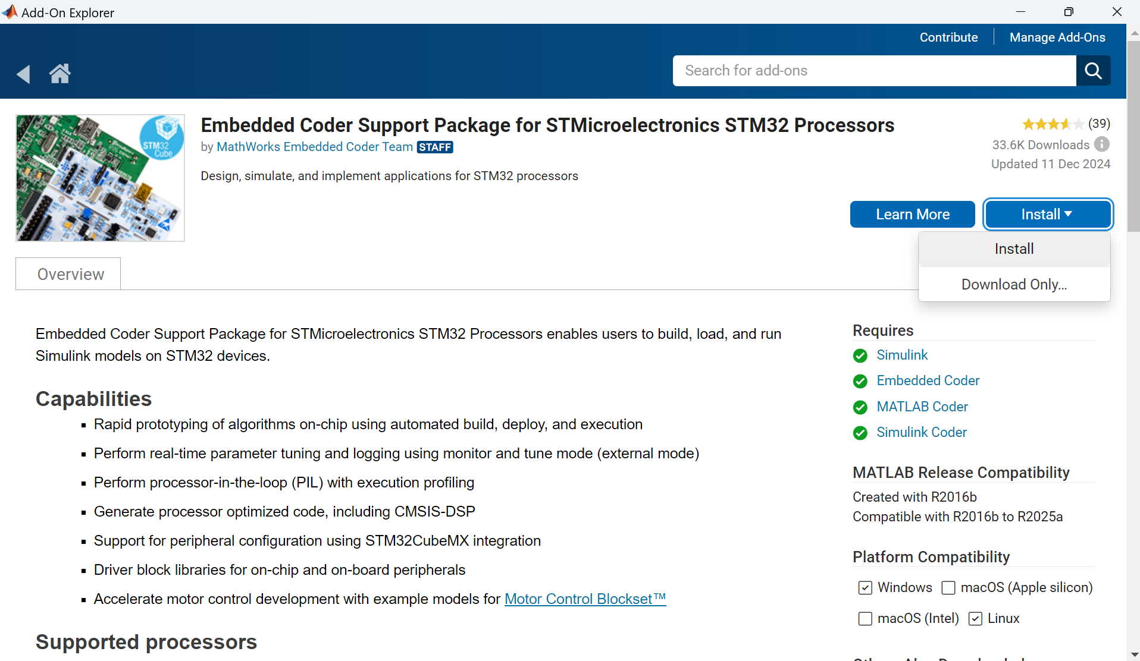

1. After installation, click "Setup Now."

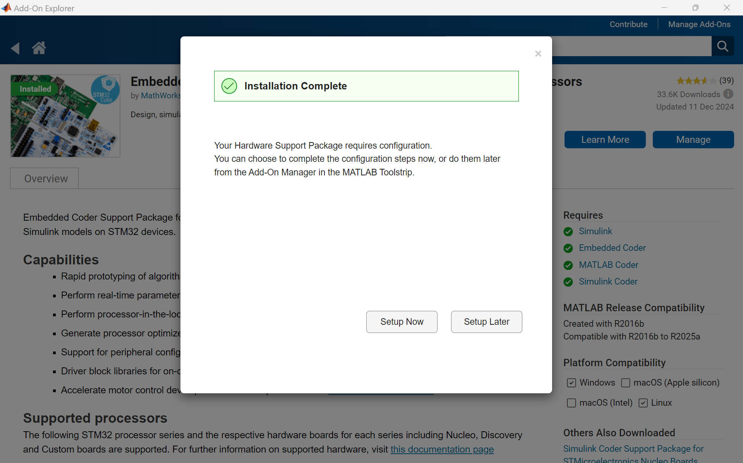

1. Check only STM32F3xx and click "Next."

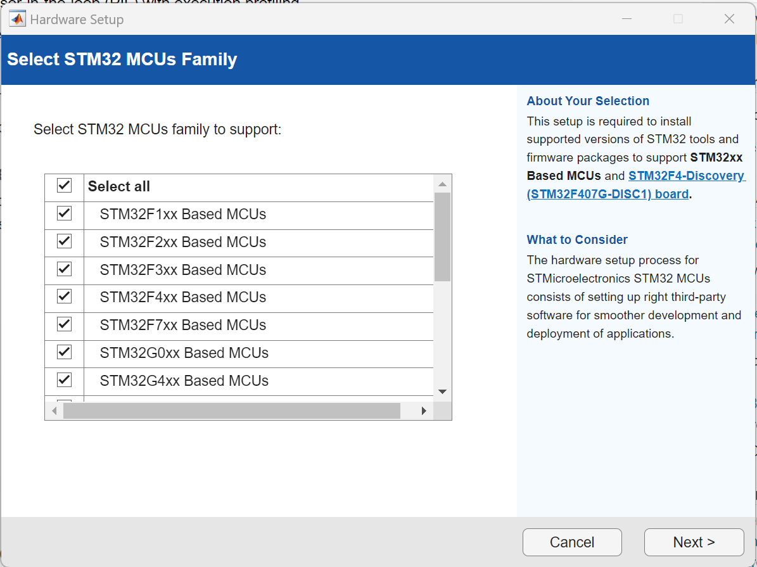

1. In the Third Party Tools window, install the required software and firmware.

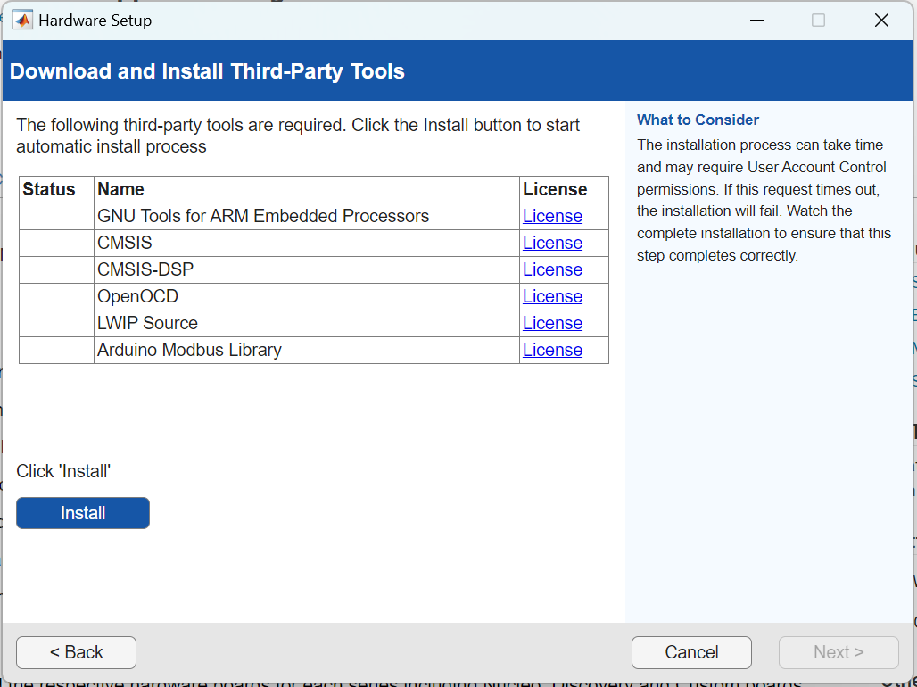

1. Download and install STM32CubeMX v6.4 (and go same step later for STM32CubeProgrammer v2.6.)

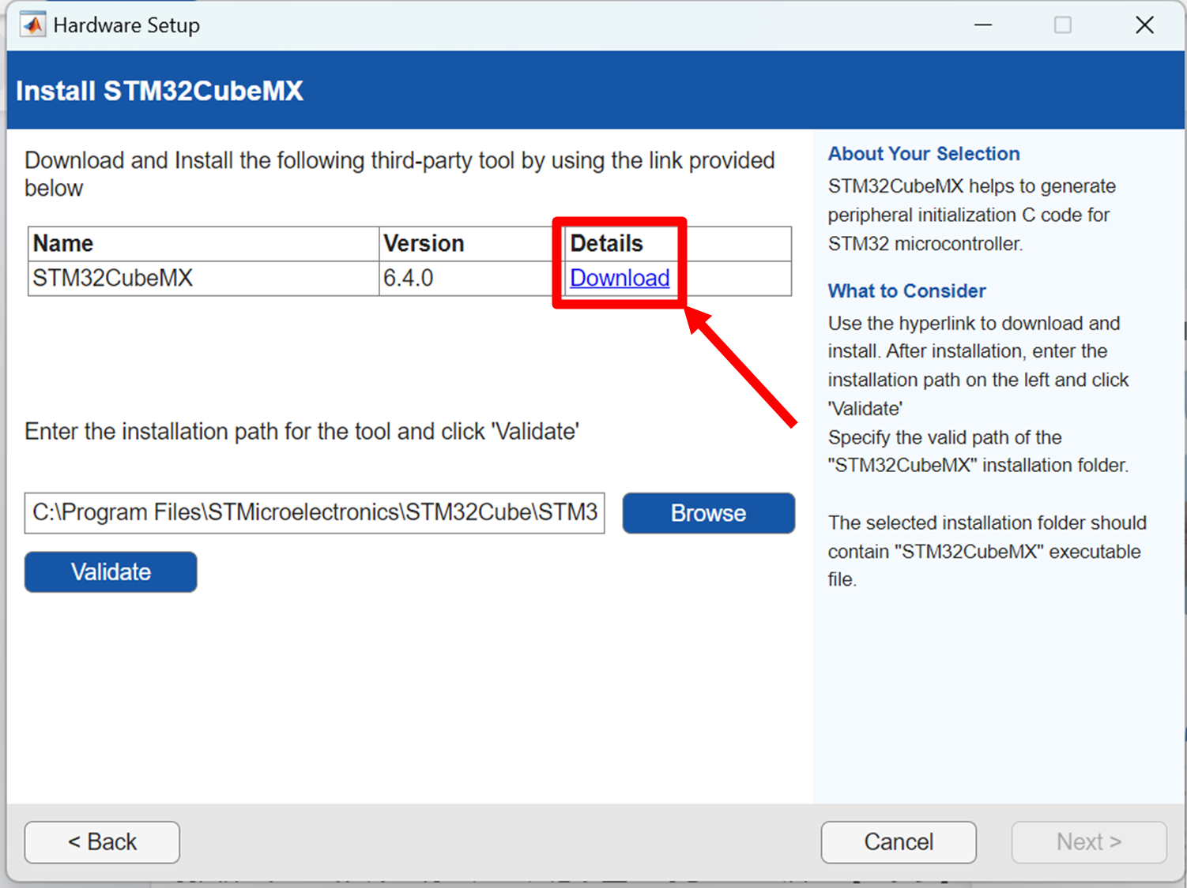

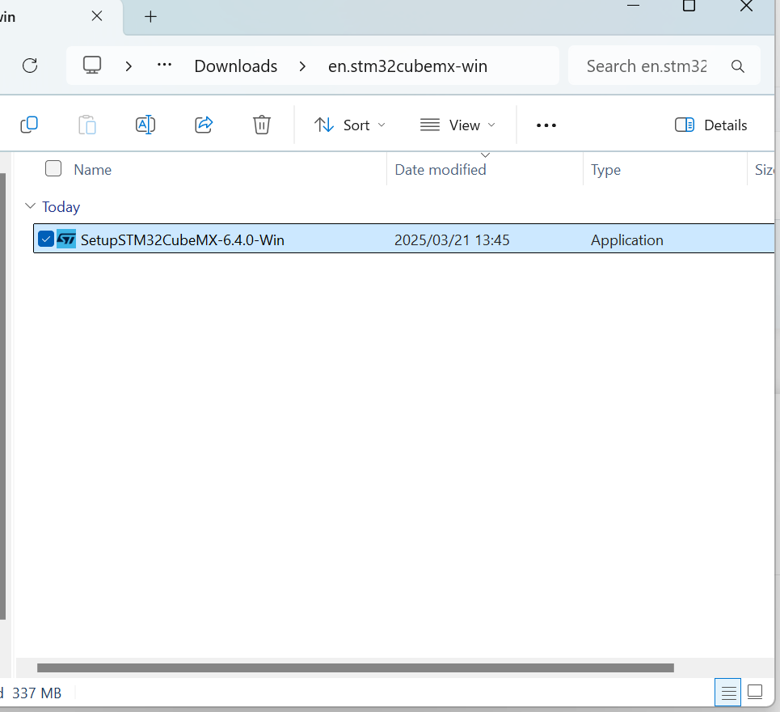

1. Specify the installation path and validate.

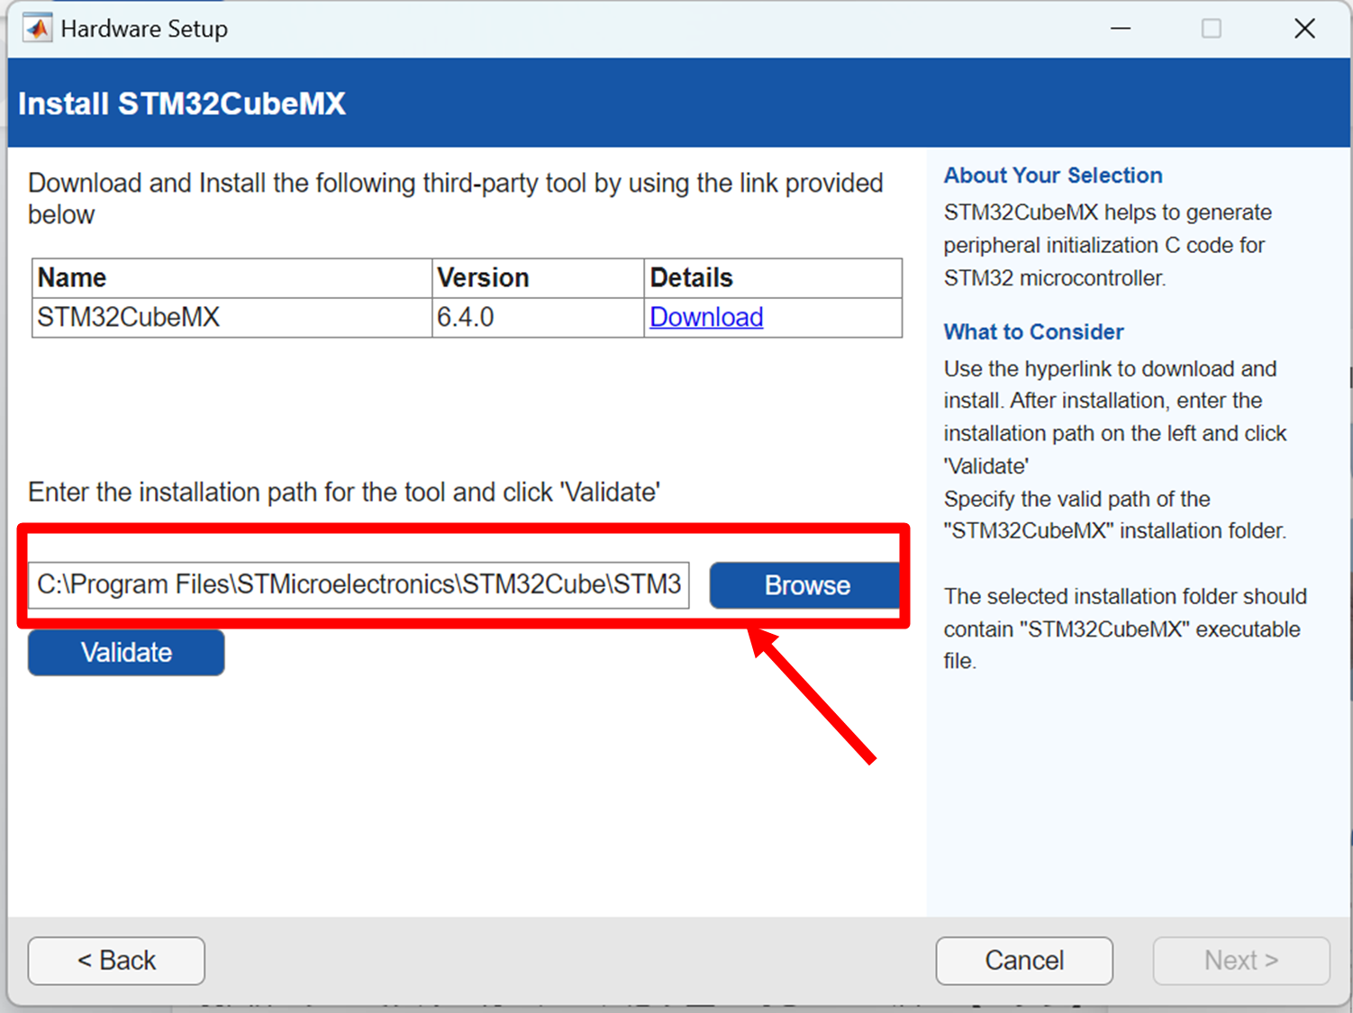

1. Install the firmware.

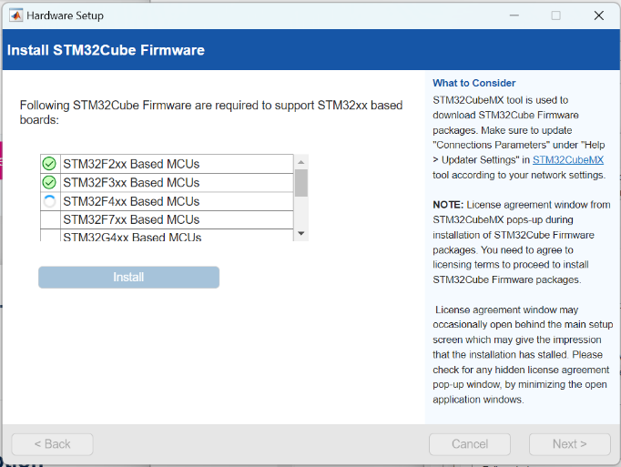

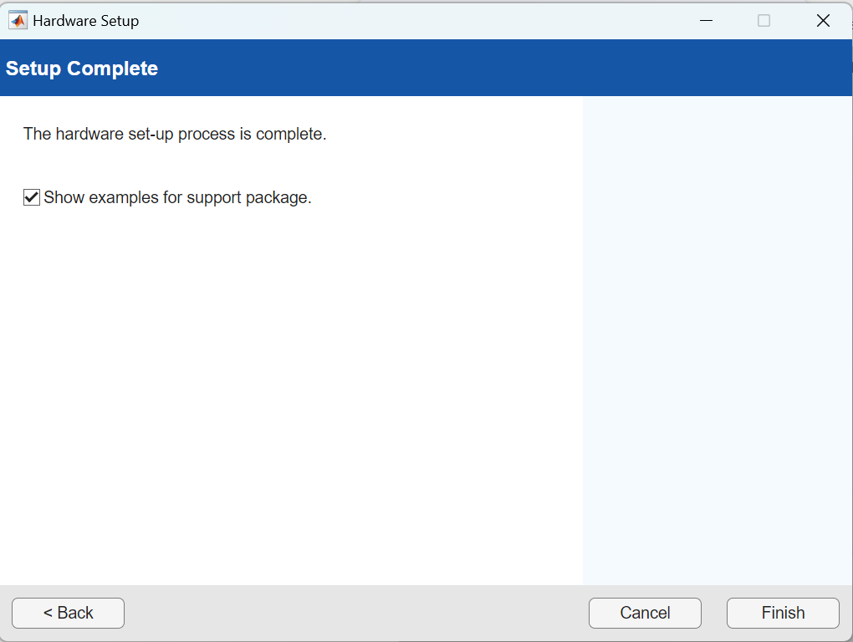

**4.2.1 Simulink Configuration**

1. Set **Modeling** → **Model Settings** → **Hardware Implementation** → **Hardware board** to **STM32F3xx Based**.

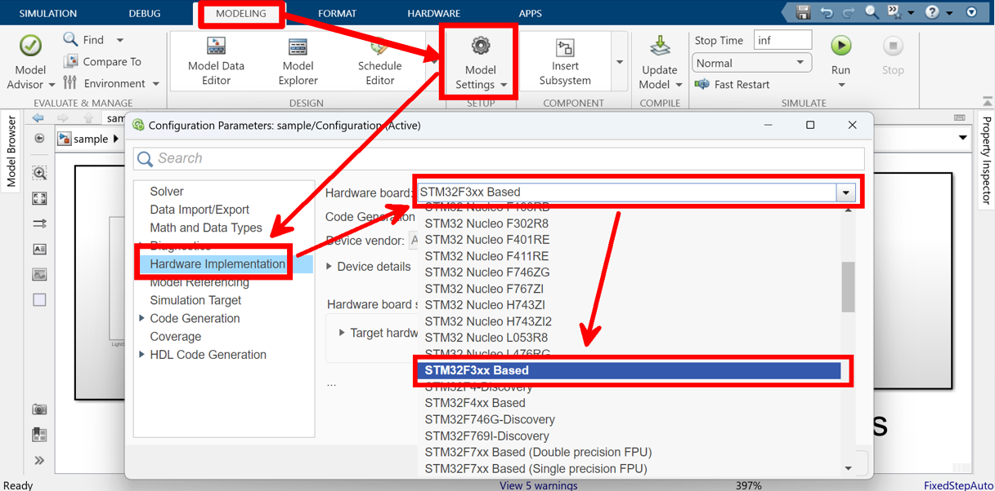

1. Set **Hardware Implementation** → **Target Hardware Resources** → **Connectivity** → **Serial Port** to the COM port number confirmed in the PC’s Device Manager.

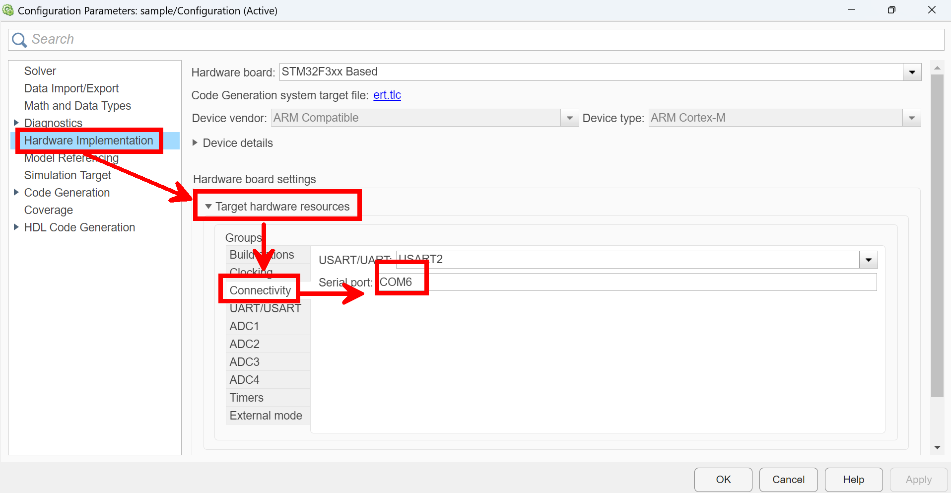

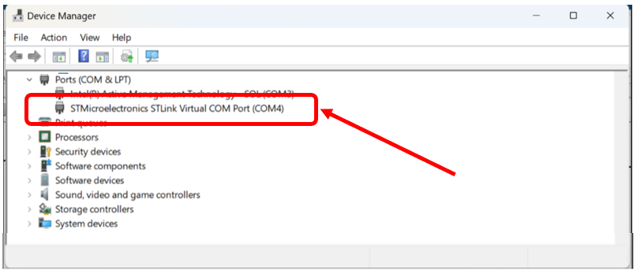

1. Creating/selecting the **.ioc** file:
   * If not available: **Build Options** → **Create** → specify project name and save location → select **NUCLEO-F303K8** in **Select Hardware**.
   * 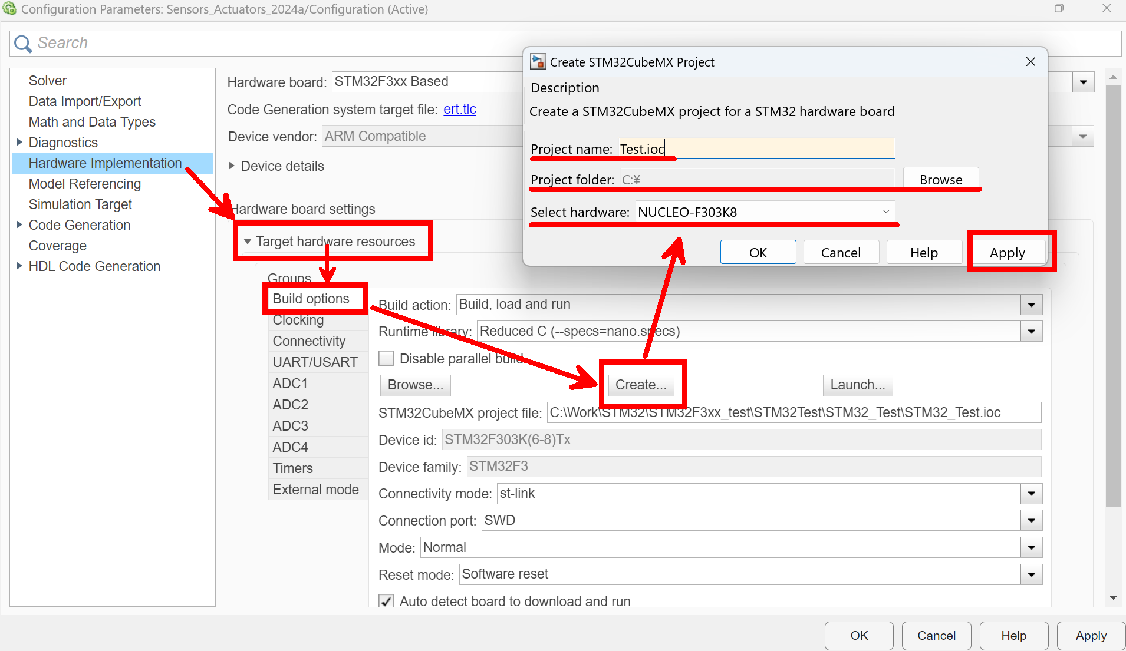
   * If available: select via **Browse**.
   * 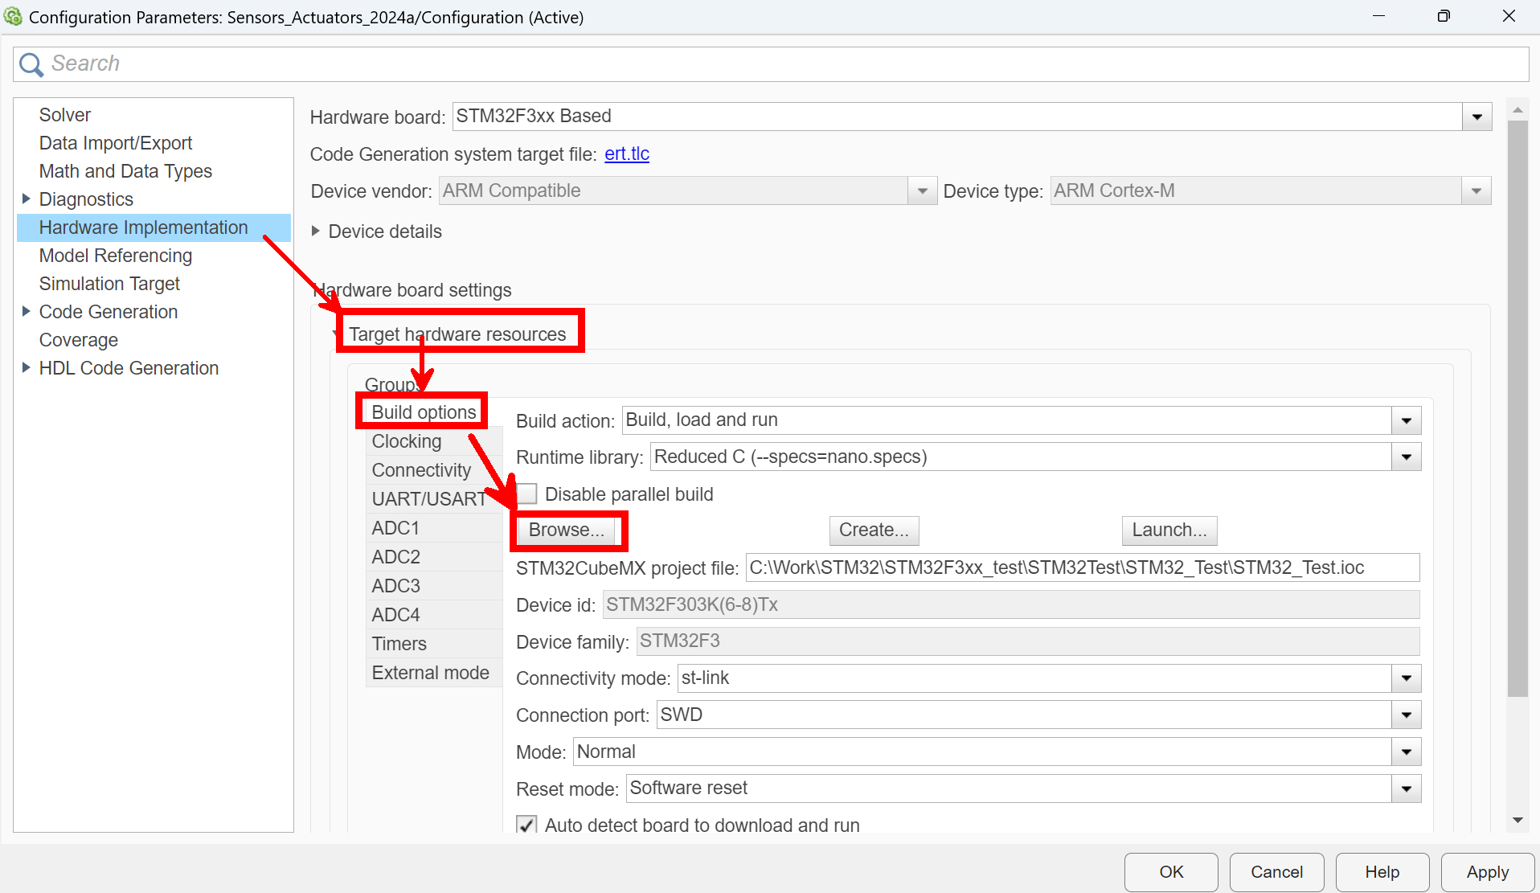
2. Execution methods from Simulink are "Monitor & Tune" or "Build, Deploy & Start."
   * Monitor & Tune: Real-time signal acquisition (USB connection required), **Faster Runs**.
   * 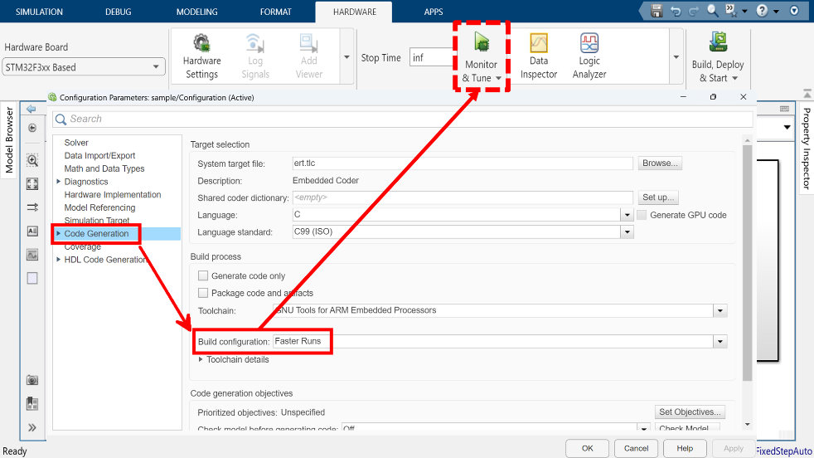
   * Build, Deploy & Start: Standalone operation (logging requires separate setting), **Faster Builds**.
   * 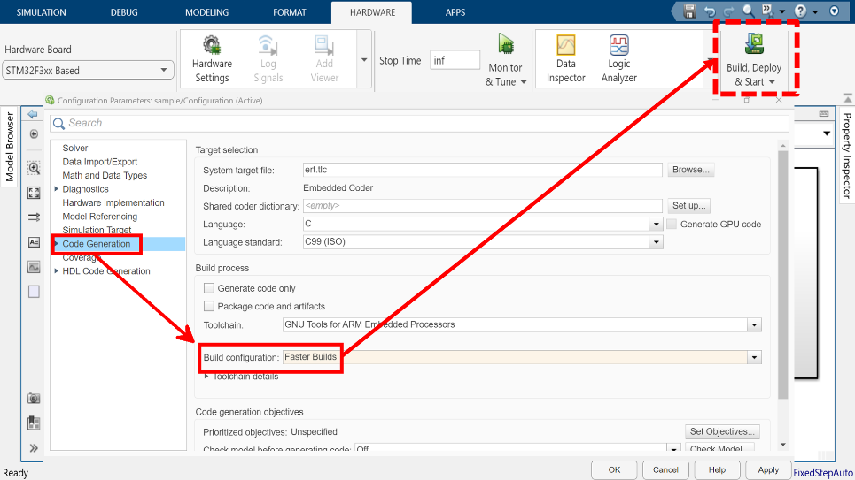

**4.2.2 STM32CubeMX Configuration**

**Training Tracer Version1 (Previous Version)**

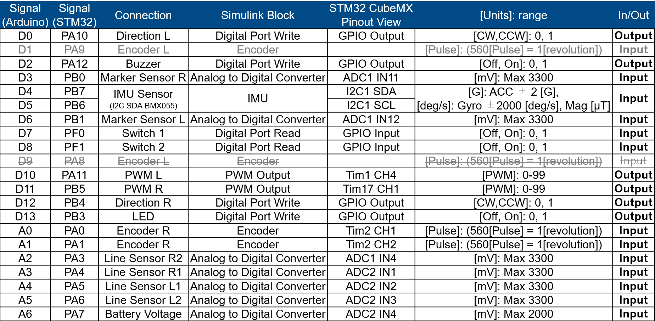

**Training Tracer Version 2 (New Version)**

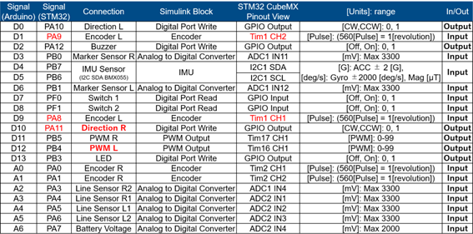

* Pin assignments differ depending on the version of the Training Tracer. Confirm the device version and configure the connection destinations in Pinout View of the **.ioc** file. **Model Settings → Hardware Implementation → Launch**
* 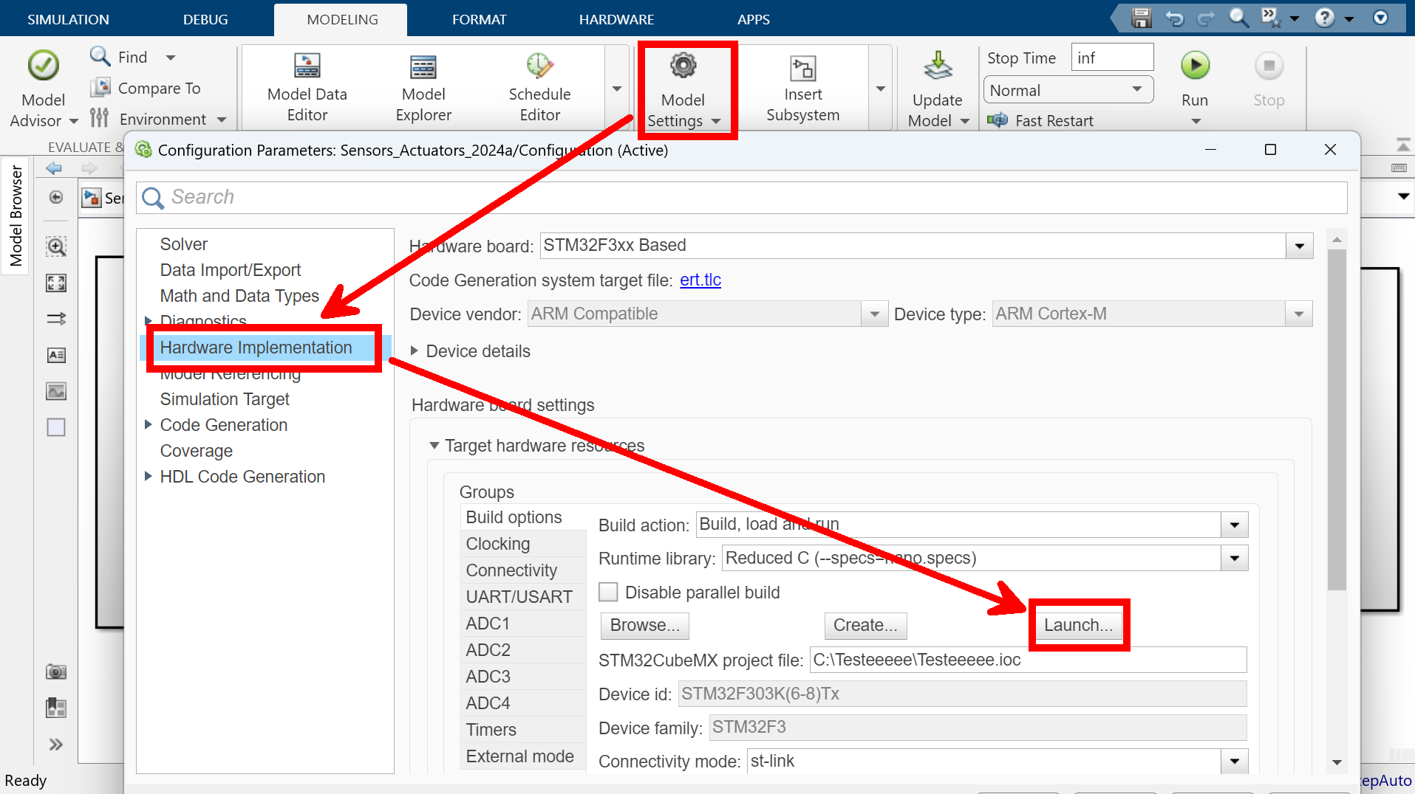
* 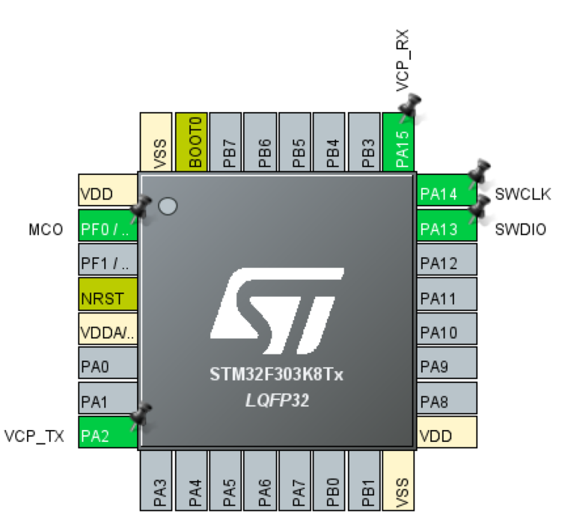
* 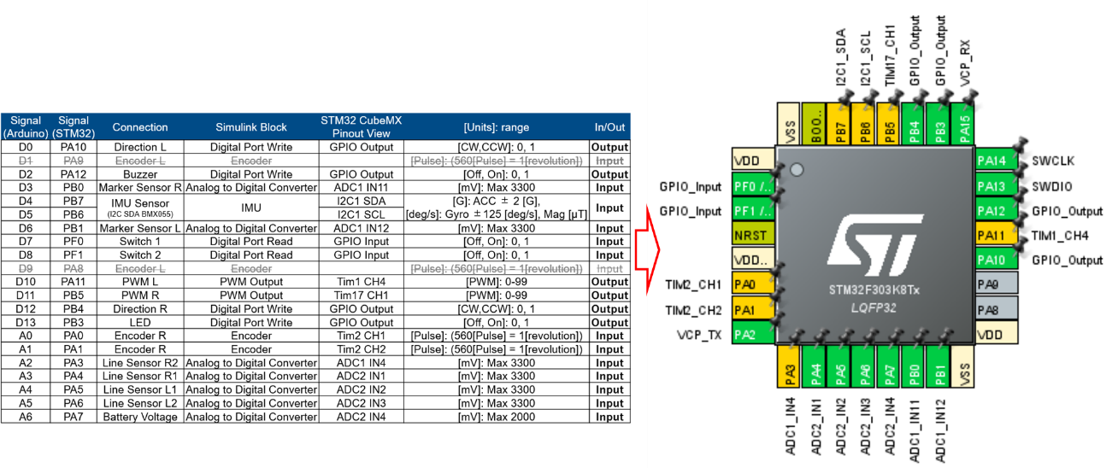
* Connect the switch block to **GPIO_Input** and set pull-up. **GPIO → PF0 and PF1 → GPIO Pull-up/Pull-down → Pull up**
* 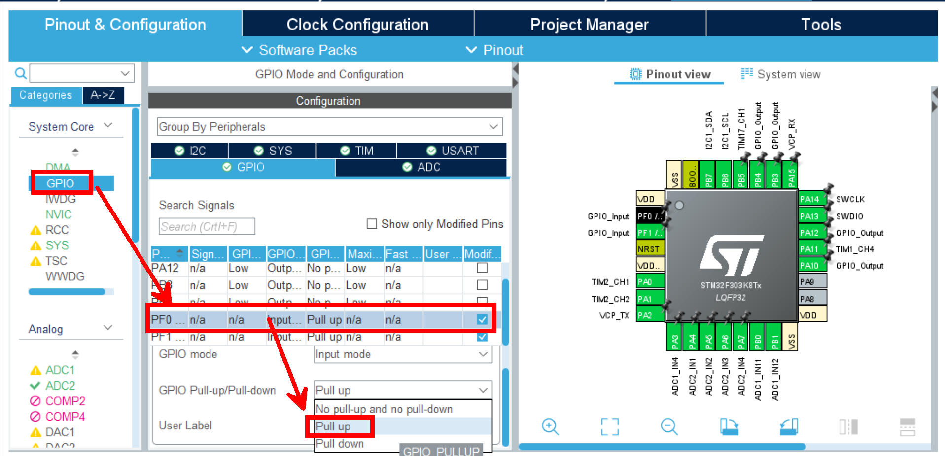
* Change the assignment of the TIM2 timer (for the right motor encoder, use TIM3). **System Core → SYS → Timebase Source → TIM3**
* 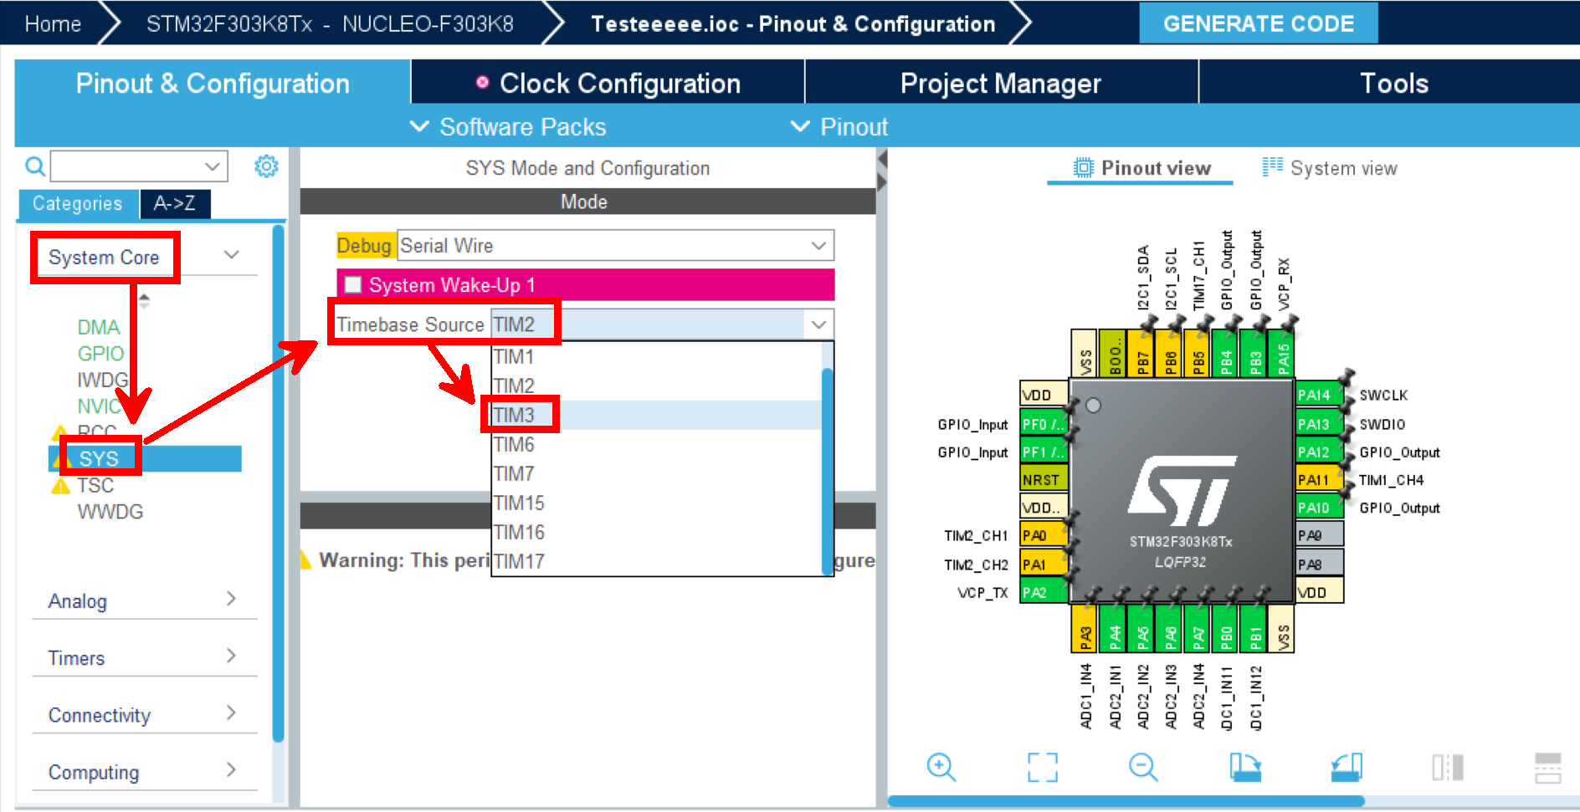
* Enable ADC1/ADC2 and set the mode to **Single-Ended**.
  + ADC1: IN4, IN11, IN12 (3 signals).
  + 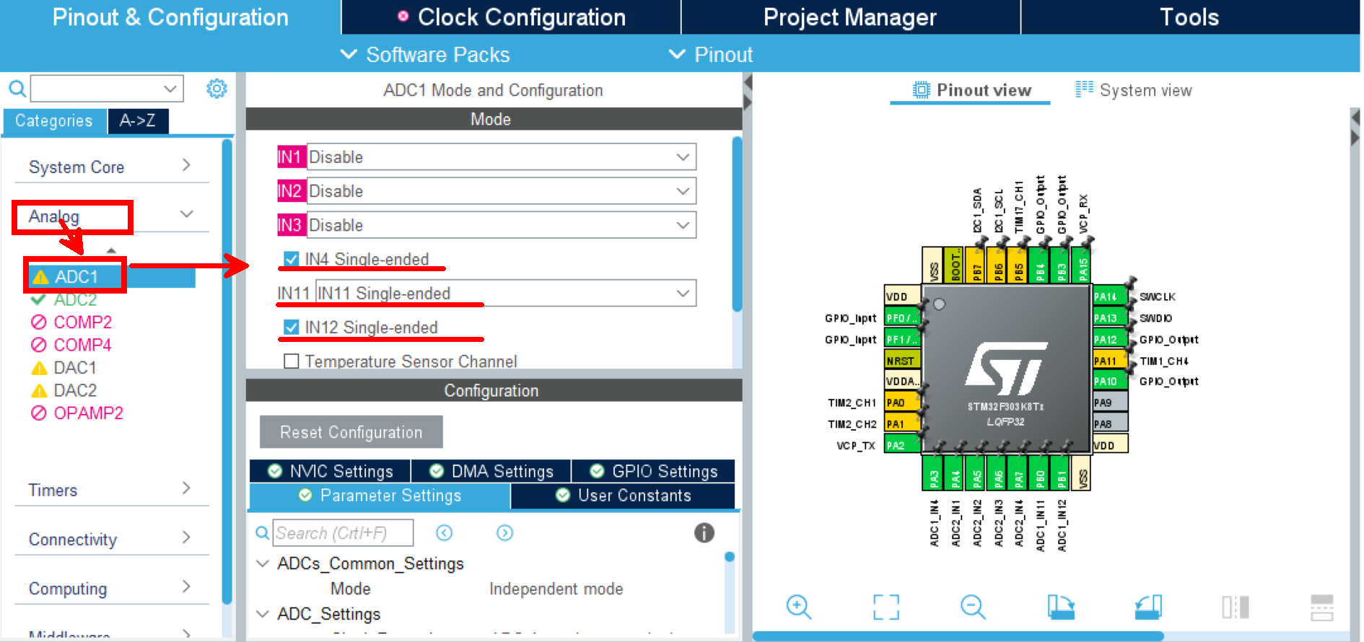
  + 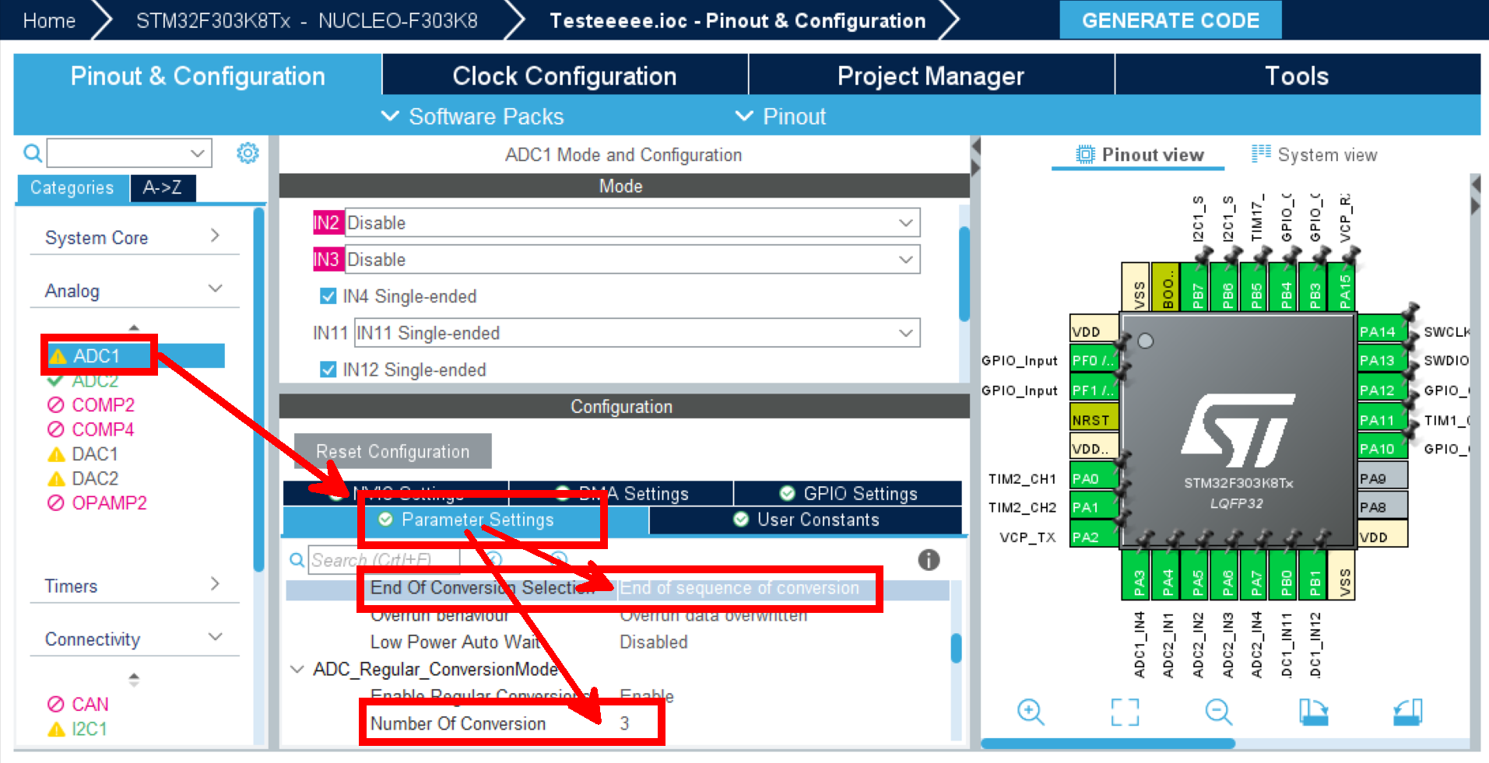
  + ADC2: IN1, IN2, IN3, IN4 (4 signals).
  + 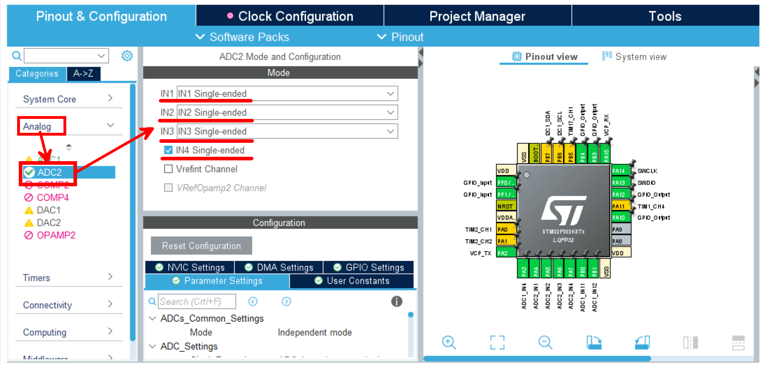
  + 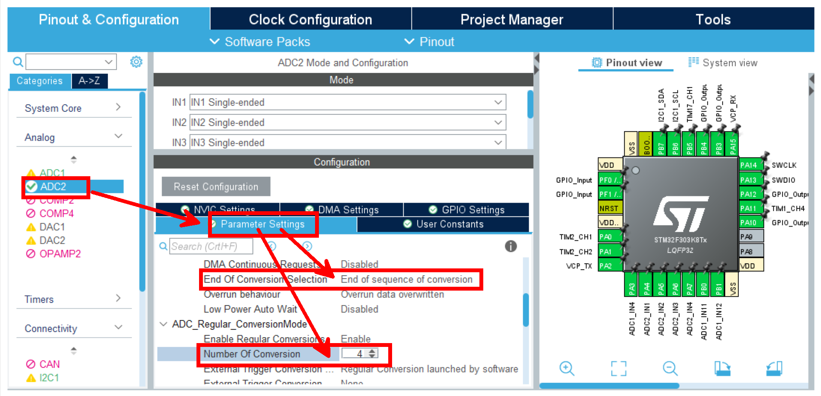
* Enable TIM2 encoder mode and select Encoder Mode TI1 and TI2. **Timers → TIM2 →Combined Channels → Encoder Mode**
* 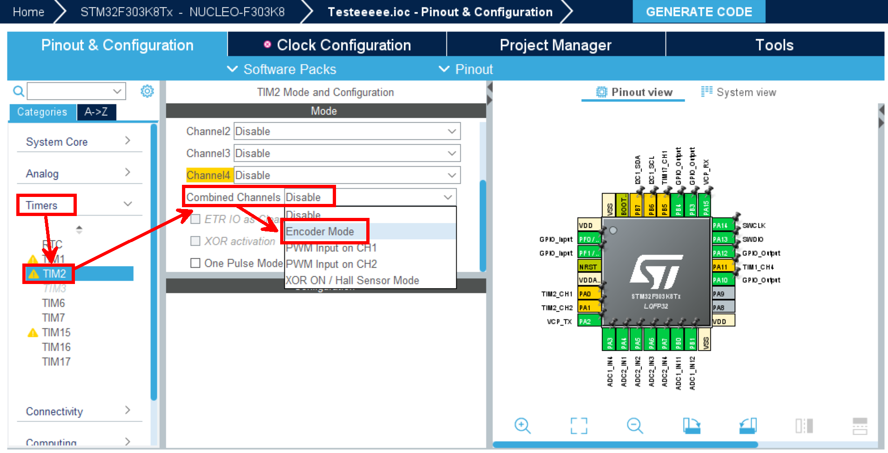
* 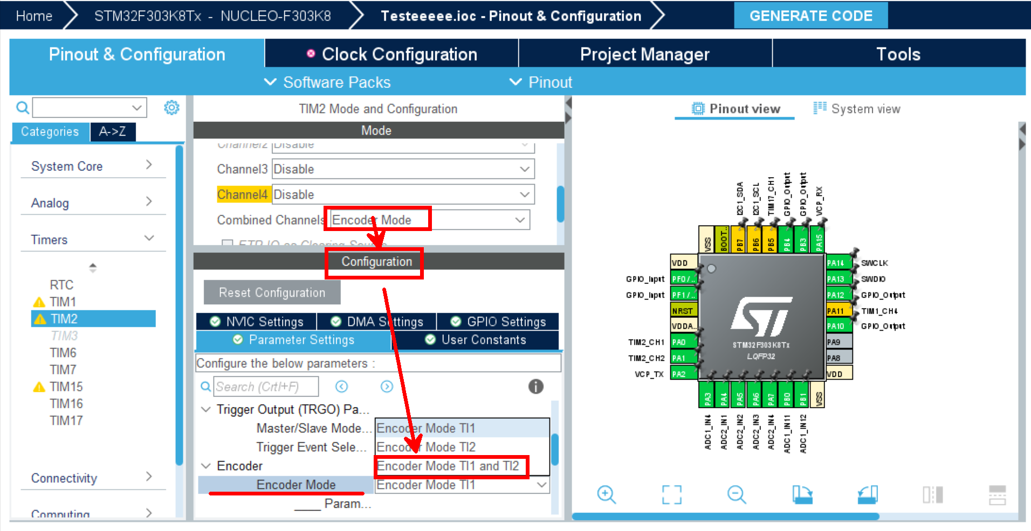
* For PWM: enable TIM1 CH4 for the right motor and TIM17 CH1 for the left motor.
* 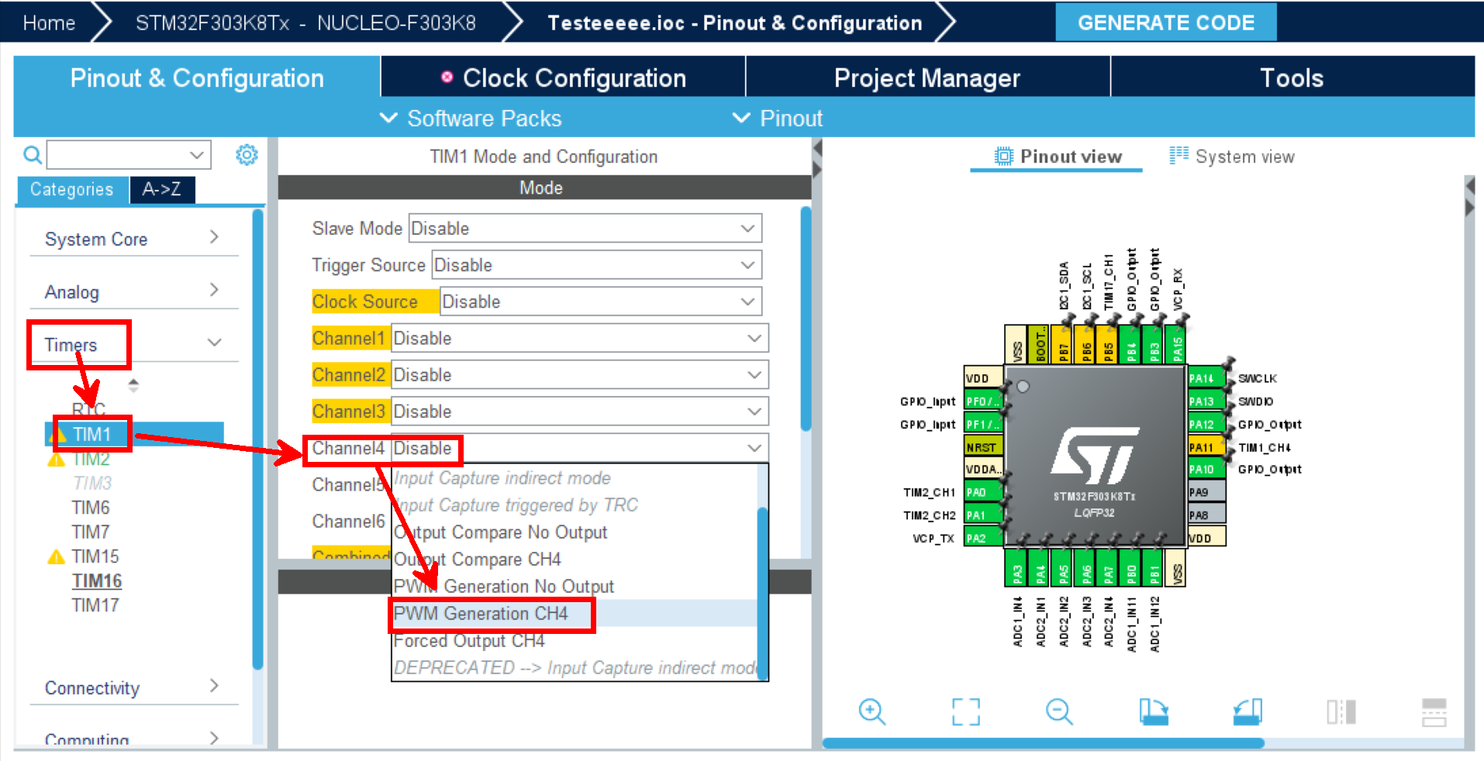
* 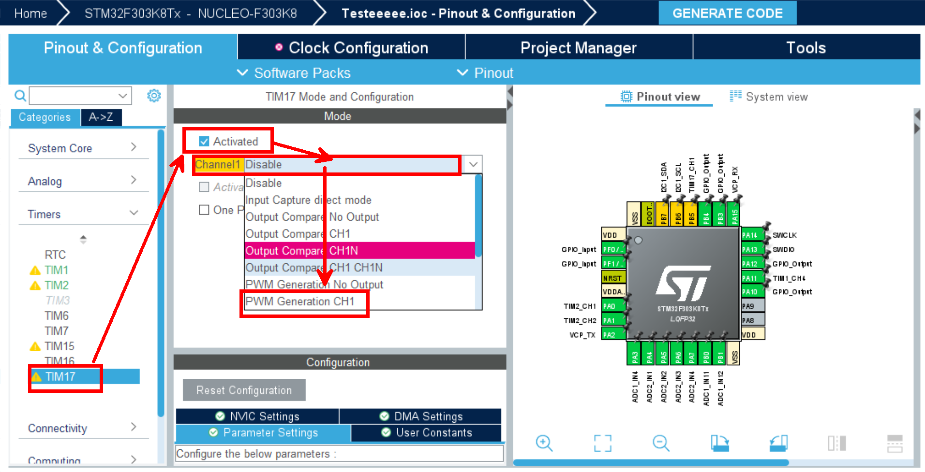
* Enable I2C1 for the IMU. **Connectivity → I2C1 → Mode → I2C**
* 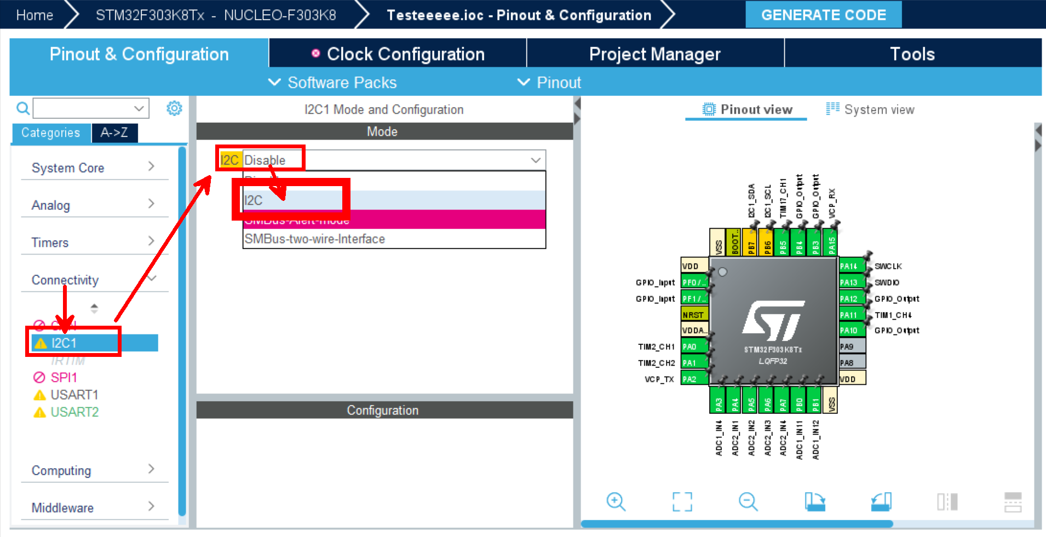
* Set the clock: HCLK to 64MHz.
* 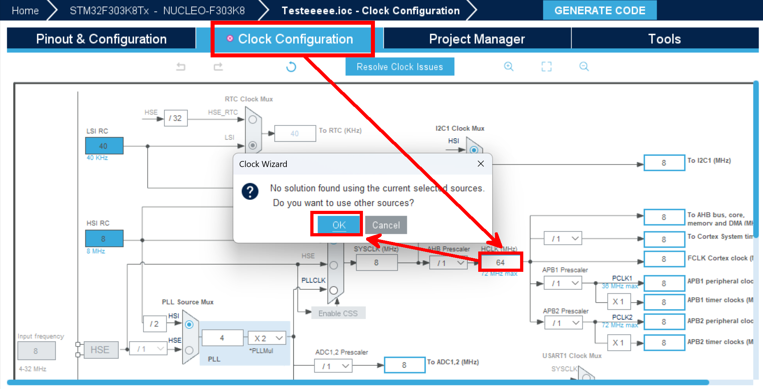
* In Project Manager, set all Driver Selectors to "LL" and uncheck all Generated Function Call options. **Project Manager → Advanced Settings→ Driver Selector → ADC, I2C, TIM**
* 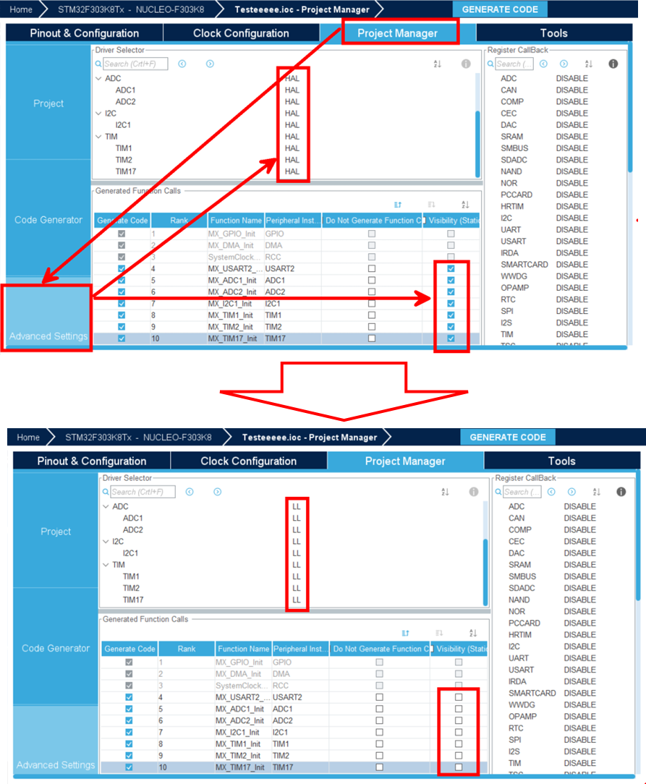
* Save the configuration with Ctrl+S.

**4.3 Overview of STM32F3 Series Blockset**

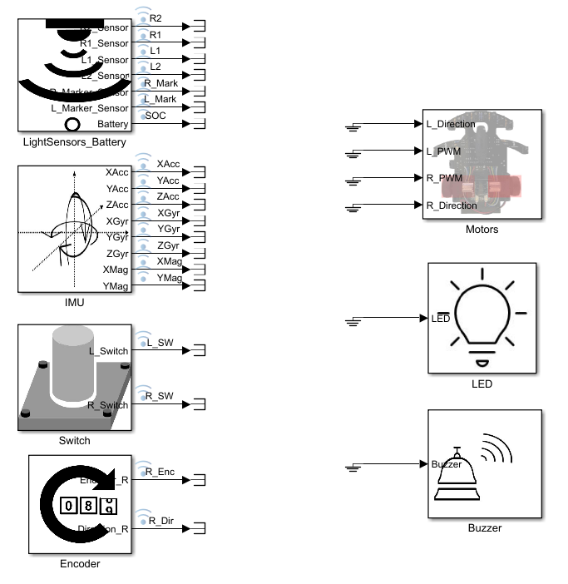

**4.3.1 Input Blocks**

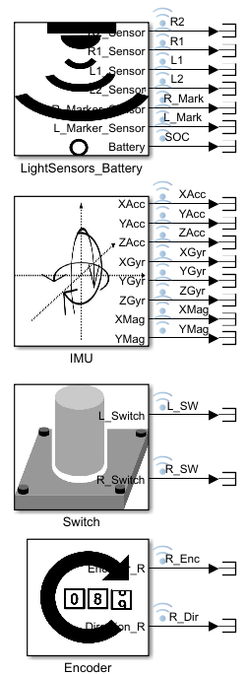

* **LightSensors_Battery**: Converts analog signals to digital using ADC1 and ADC2.
* 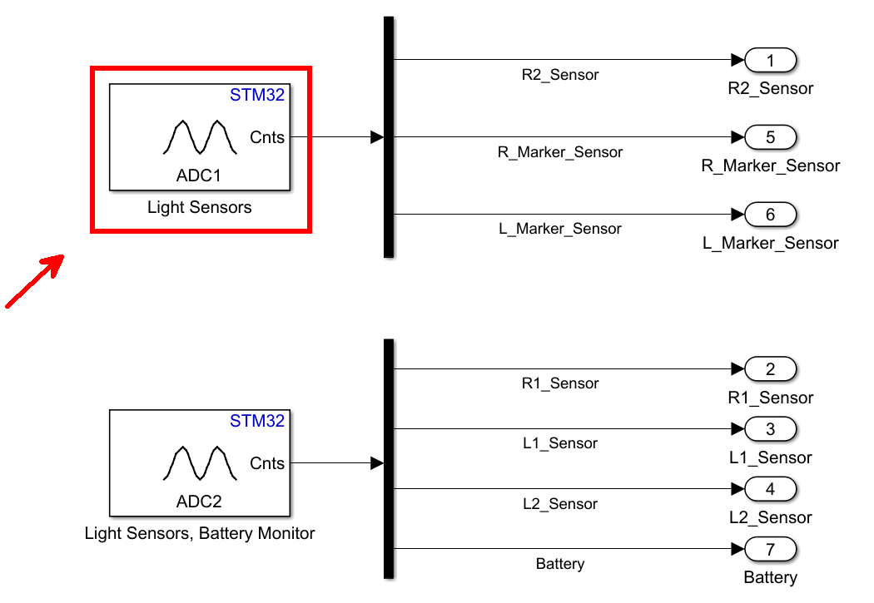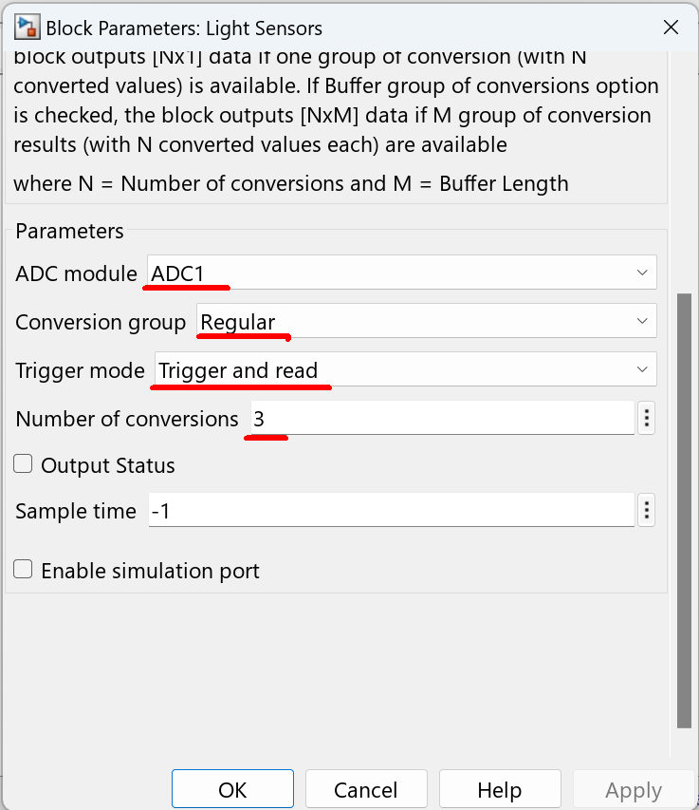
* **IMU**: Uses BMX055, connected via I2C Controller Read/Write block.
* 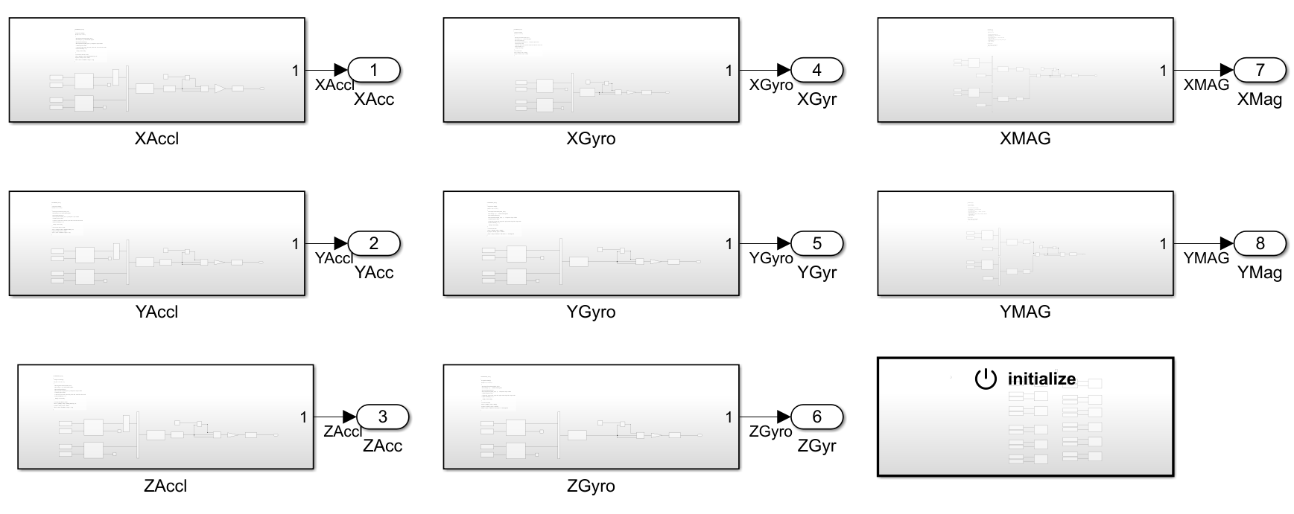
* **Switch**: Configures GPIOF’s PF0/PF1 using Digital Port Block.
* 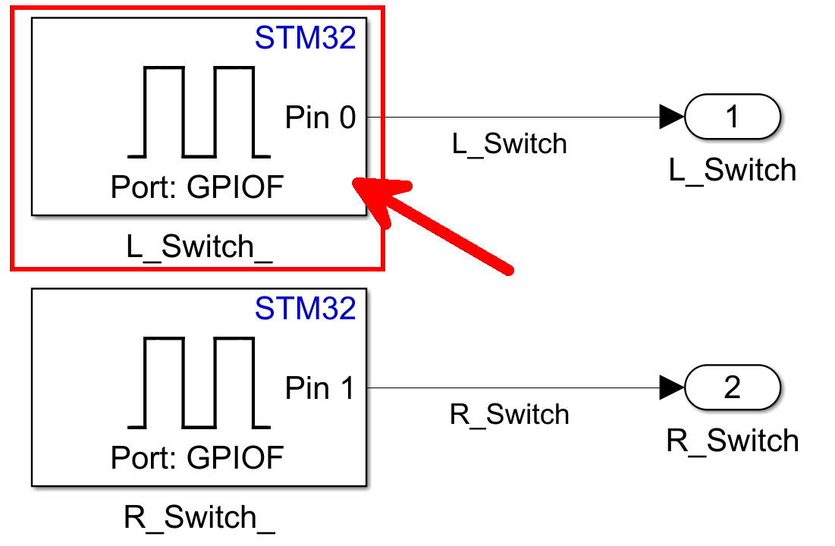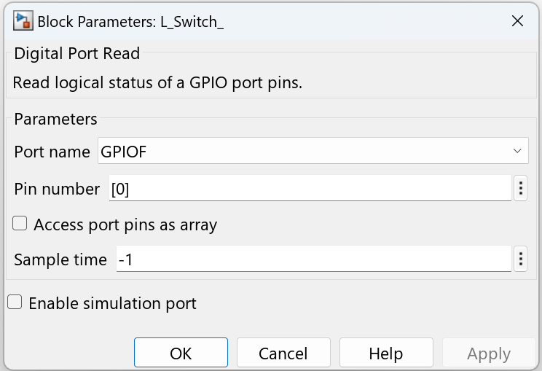
* **Encoder**: Encoder block; Ver1 supports only the right encoder, Ver2 supports both.
* 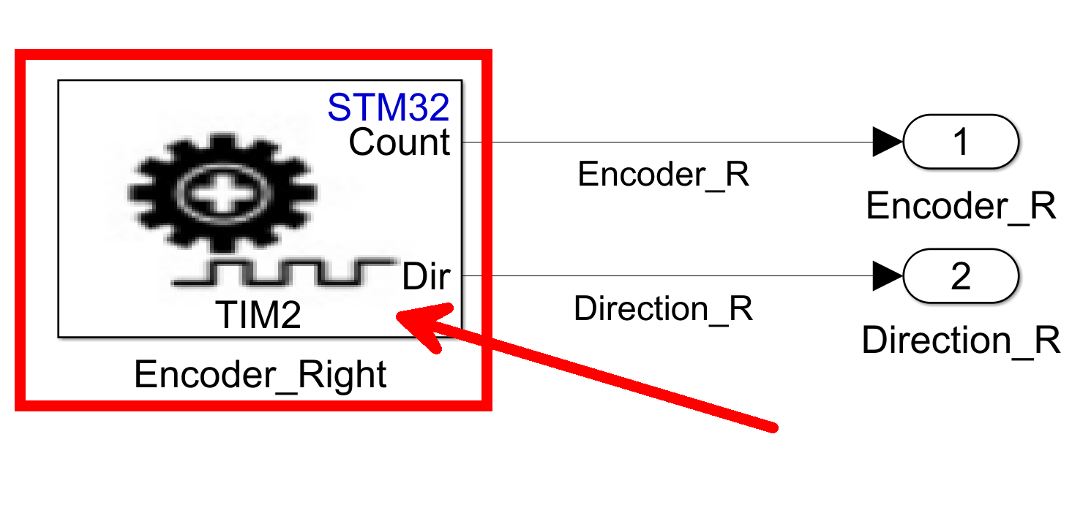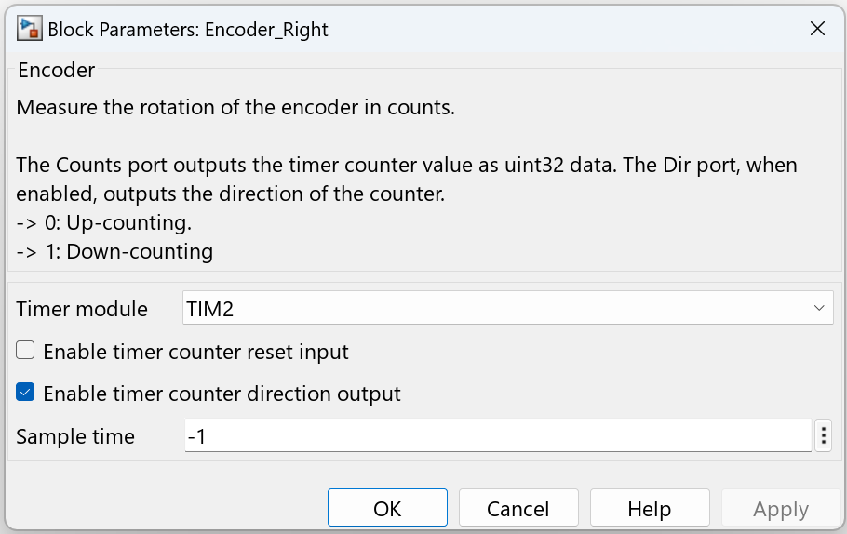

**4.3.2 Output Blocks**

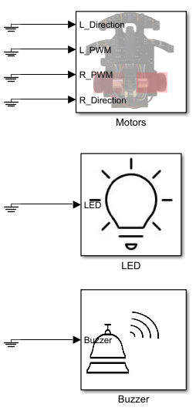

* **Motors**: Controls left and right motors via Digital Port Write and PWM blocks (e.g., PA10, TIM1 CH4).
* 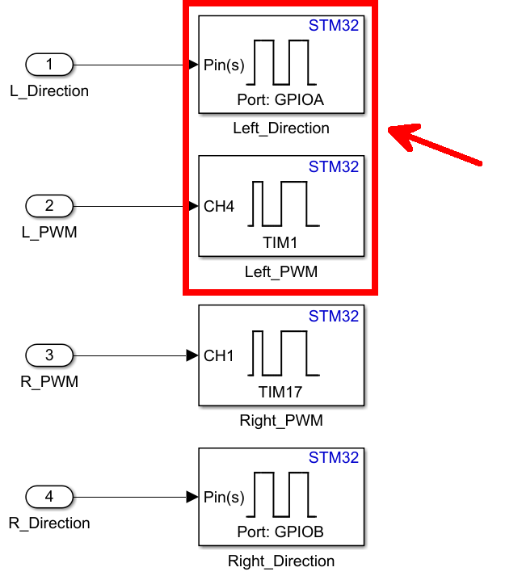
* **LED**: Controls PB3 via Digital Port Write.
* 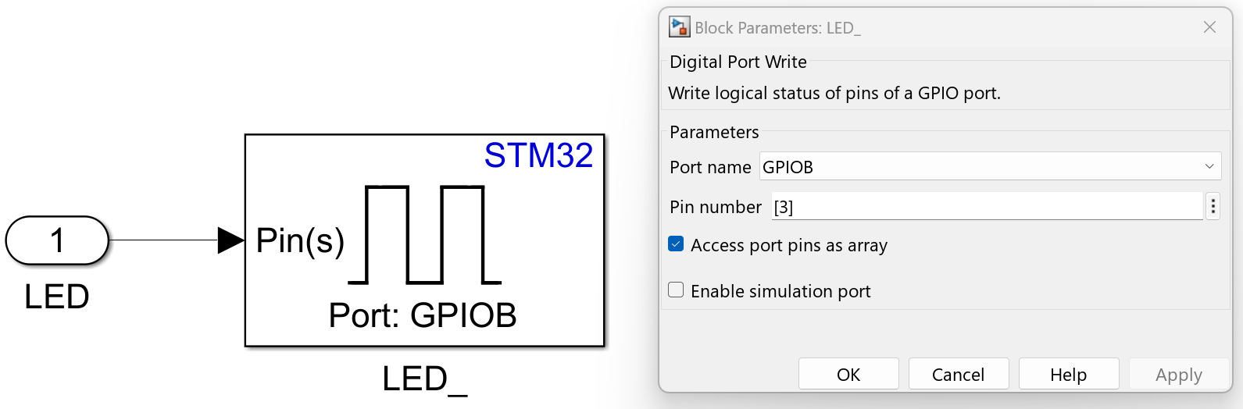
* **Buzzer**: Controls PA12 via Digital Port Write.
* 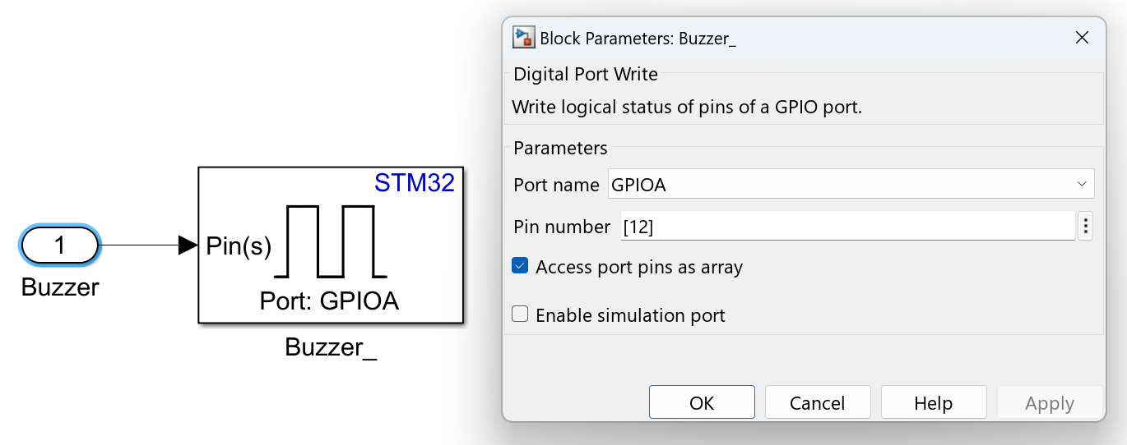

**4.4 Implementation on Actual Hardware**

1. Install batteries in the tracer and connect it to the PC via USB cable.

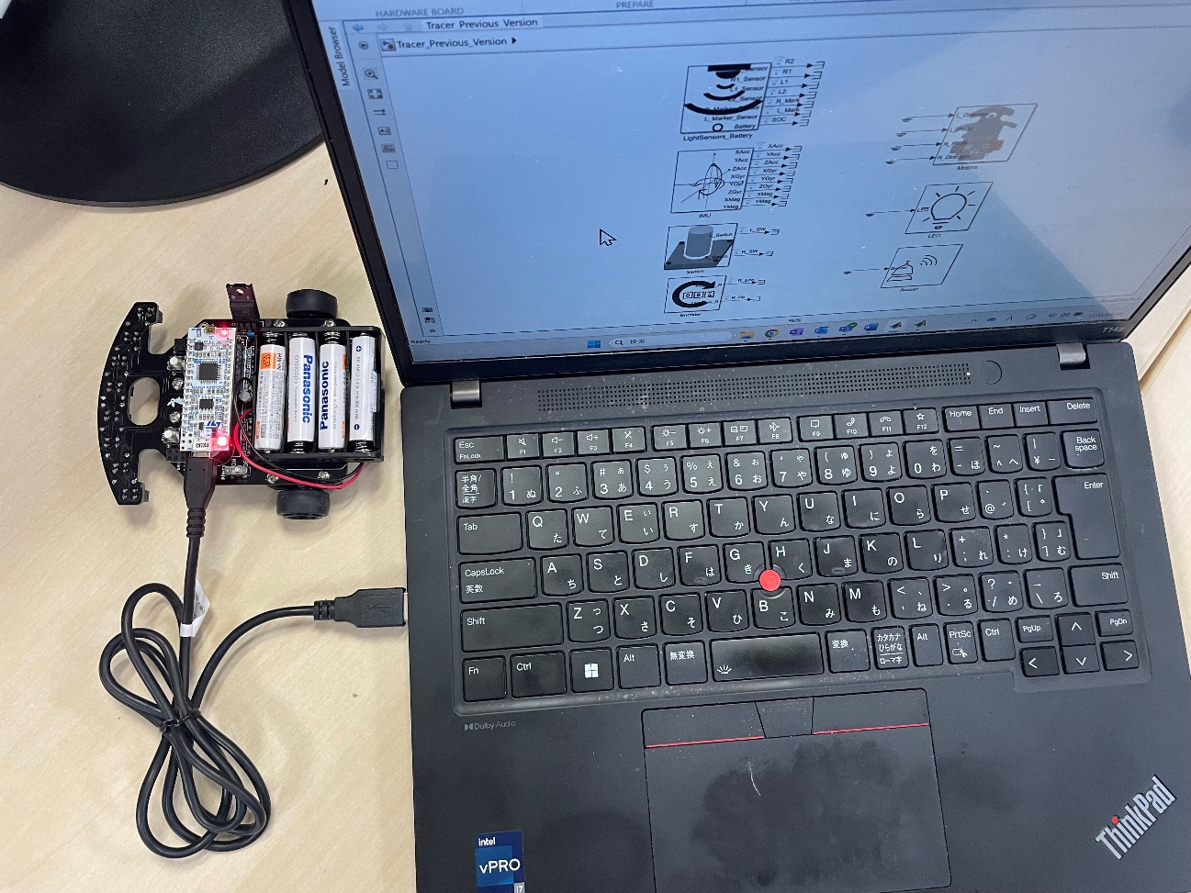

1. Confirm the port number in Device Manager and ensure it matches the Simulink Hardware Setting.



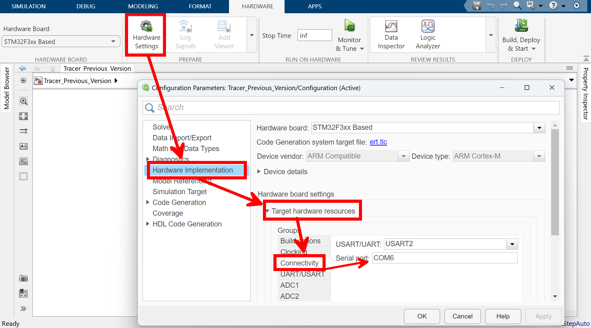

1. Choose the execution method: "Monitor & Tune" or "Build, Deploy & Start."
   * **Monitor & Tune**: Faster Runs (enables real-time signal acquisition, USB required).
   * 
   * **Build, Deploy & Start**: Faster Builds (standalone operation, separate configuration required for logging).
   * 
2. Results can be verified in real time using Monitor & Tune mode.

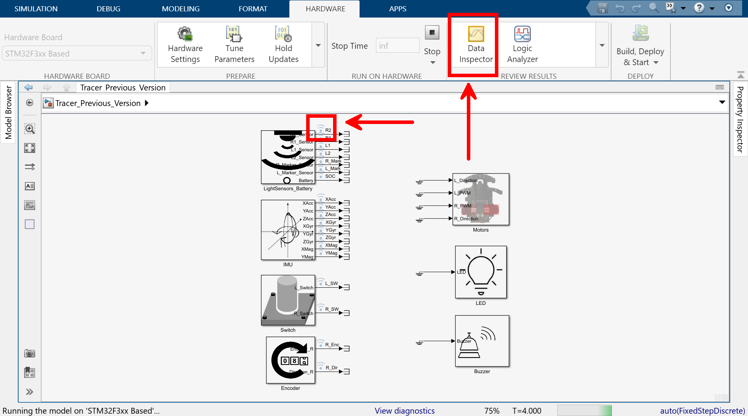

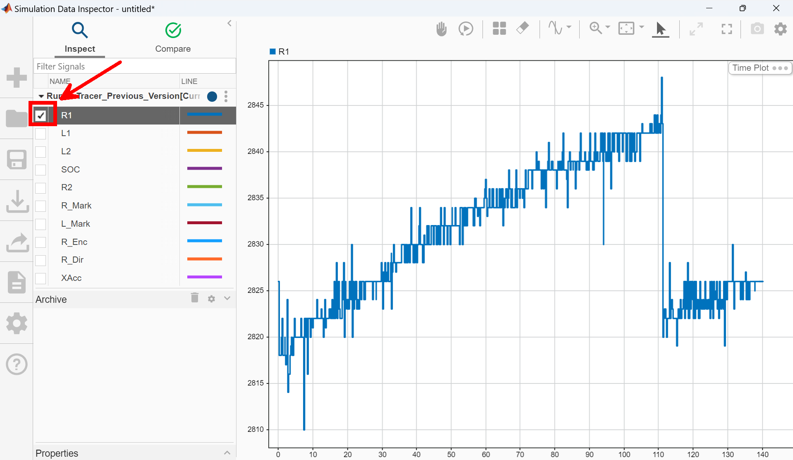

By deploying control algorithms verified in the simulation environment to actual hardware, it is possible to operate with a clear understanding of risks and operating conditions prior to implementation. This approach is expected to improve development efficiency and product quality.